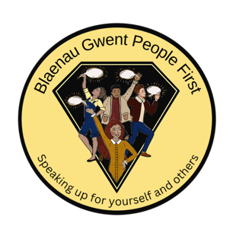

Blaenau Gwent People First - Creative Hackathon Event
17th November 2025, 10 am. Llanhilleth Miners Institute

Booking form:

Name: ----------------------------------------------------------------------------------------------------

Email address:-------------------------------------------------------------------------------------------

Dietary Requirements

I confirm that I will be attending the Hackathon Event on 17th November 2025.

Please return booking form to dawn@rctpeoplefirst.org.uk
Closing date for bookings Monday 3rd November 2025

