Local Welsh Learner Triumphs at The National Eisteddfod
- 11th November 2024

It is with immense pride that we introduce Antwn Owen-Hicks from Sirhowy, Tredegar, who has been honoured with the prestigious Welsh Learner of the Year award at this year’s National Eisteddfod, held in August at Ynys Angharad Park, Pontypridd. For the past 30 years, Antwn's unwavering dedication to learning Welsh has been driven by his passion for music and his role as a founding member of the band Carreg Lafar.
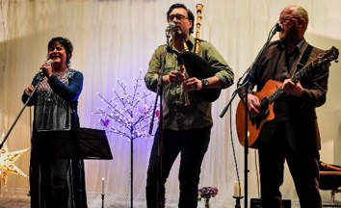
Originally from Pontllanfraith and moving to Canada, then returning at the tender age of 7, Antwn was initially enrolled in an English medium school. His journey towards embracing his Welsh heritage truly began while studying art in London. Feeling a profound disconnect from his roots, he turned to Welsh folk music, which sparked a deep and enduring love for the language.
Through persistent effort and a commitment to mastering Welsh, Antwn attended various language courses and achieved fluency. His journey was greatly supported by his bandmates and his wife, Linda, as well as his professional work with the Arts Council of Wales, where he used Welsh daily.
Remarkably, Antwn’s daughter is the first in their family to speak Welsh from birth since his great-grandmother, weaving the language back into the fabric of their daily lives. He encourages other learners to embrace their mistakes, believing that every bit of Welsh spoken is a step towards greater fluency.

Antwn continues to champion Welsh culture through his music and numerous arts projects. He is currently engaged in ‘A Song for the Valleys,’ a project aimed at creating new traditional folk music with local communities. His dedication to the Welsh language has opened countless doors, enriching his life beyond measure, and he aspires to inspire others to embark on their own language learning journeys.
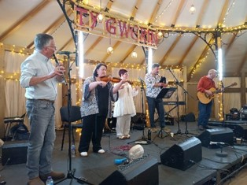
Reflecting on his journey, Antwn says, “I can’t imagine how different my life would be if I hadn’t started learning Welsh. It has made a tremendous difference; it has opened so many doors for me, introduced me to wonderful friends, and connected me to a vibrant community. You truly never know the impact until you begin.”
Antwn’s story is a powerful testament to the transformative power of embracing one’s heritage and the boundless opportunities that come with learning a new language.

