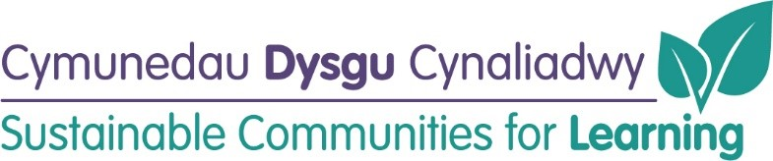

Rhos y Fedwen Primary School Remodelling (Band B)
(updated June 2022)
Timeline for Delivery:
Business Case: | Submitted and Approved
Site investigations: | Summer 2021
Project brief: | Summer 2021
Tender document preparation/ detailed design work: | Spring 2022
External (3G)  Building regulation/planning applications to be submitted: | Spring/Summer 2022
Out to tender: | Autumn 2022
Contractor appointment: | Autumn 2022
Commencement (internal works): | Spring/Summer 2023
Commencement (external works): | Autumn 2022 (3-month contract period)
Conclusion: | Autumn 2023

Progress to Date:
Before | After
Entrance Lobby
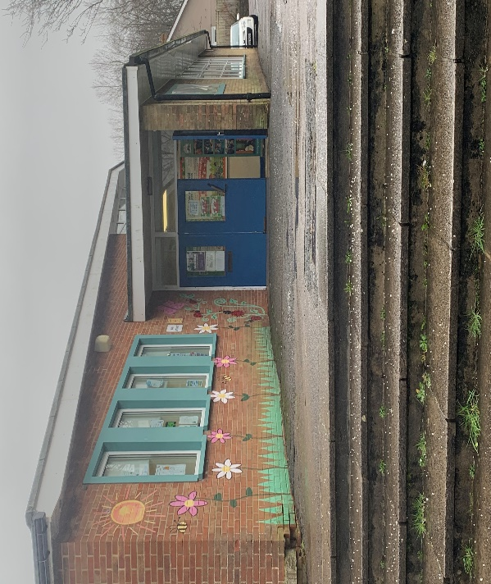

Hall Area
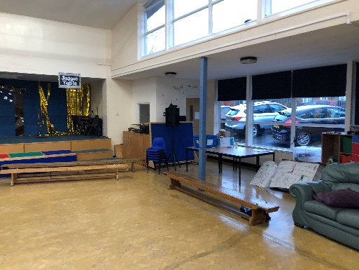

Community Room
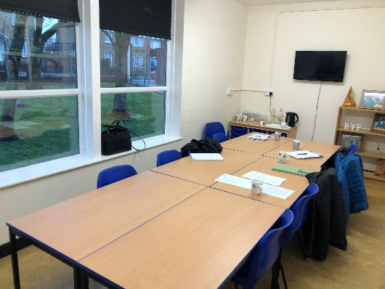

Life Skills Room
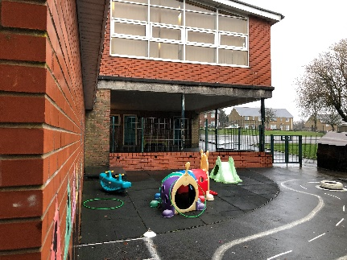

Foundation phase
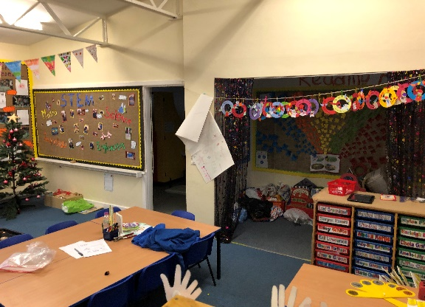

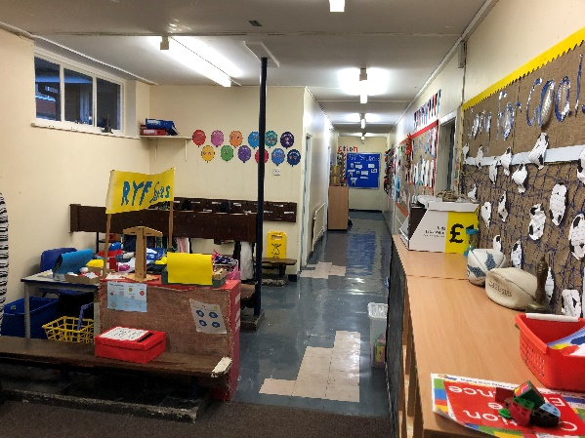

3G Pitch Area
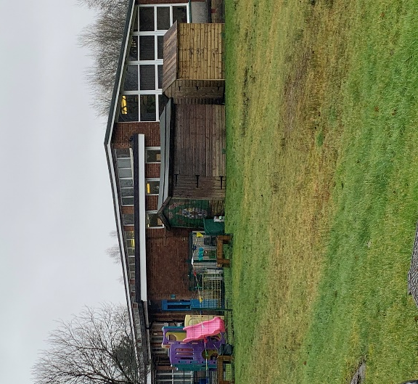
Staff Room

