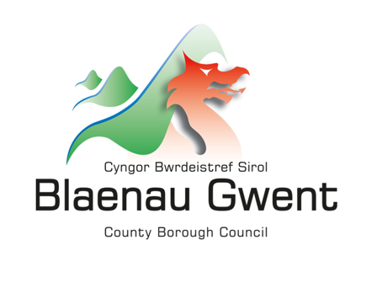

Local Growth Fund Application Form

The Fund is designed to target lagging areas with the greatest potential for productivity catch-up, helping businesses to grow, create better-paid jobs and strengthen regional economies.
The four high growth sectors in Wales are identified as Advanced Manufacturing, Clean Energies, Digital and Technologies, and Creative; and two high growth potential sectors are Life Sciences and Financial Services.
The UK Government has set two key strategic funding outcomes for the Local Growth Fund across the UK: Increased Real Household Disposable Income (RHDI) per head; and Increased Gross Domestic Product (GDP) per head.

This strand of the Fund is focused on Priority 2.
Priority 2: Increasing skills and supporting people into work
Objective 2.1: Reduce levels of economic inactivity, notably among young people, disabled people, women and people from ethnic minority backgrounds.
Objective 2.2: Enhance workforce skills through flexible, demand-led education and training aligned with needs of high-growth and regionally important sectors

The Local Growth Fund contains a mix of capital and revenue funding designed to support efforts to boost gross domestic product (GDP) and real household disposable income (RHDI) to deliver improved economies and higher living standards
Blaenau Gwent skills gaps have been identified in Digital and Creative Industries, projects that can demonstrate activities in these areas will be deemed more favourably.

The level of information provided for the application should be proportionate to the size and complexity of the project proposed.

Applicant Information

Applicant name:

Bid Manager Name and position:
Name and position of officer with day to day responsibility for delivering the project

Contact telephone number:
Email address:

Postal address:

Website:

Company Registration Number (where relevant):

Charity Registration Number (where relevant):

Public Procurement Organisation Number:

Senior Responsible Officer contact details:

Please confirm the type of organisation:

☐ Local authority
☐ Private sector
☐ Voluntary sector
☐ University
☐ FE College
☐ Other (please specify)
Click or tap here to enter text.

Value being Requested (£):

The Bid – investment priority

How does the proposal align with local needs and long-term strategic plans for local growth as defined by BGCBC’s Deal and Blueprint for Growth?

Project Summary
Project Name
Please describe in 500 words or less per question. Please be as concise as possible.
Project proposal:
Who will deliver the activities?
How will the activities be delivered?
Who will be the beneficiaries of the project?
Where will the activities take place?
When will the project start? |  |  | When will the project end?
What are the key milestones for the implementation and delivery of the project?
Milestone |  |  |  | Target Month

What experience does the organisation have of delivering this type of activity?
What Objective does the project come under?
Objective 1 ☐
Objective 2 ☐

What outcomes and outputs do you anticipate the project to achieve (please give numbers) and how will you evidence these?

How much Local Growth Fund investment is sought (Please give a breakdown of funding request. Where capital is requested please specify value, quantity and use in project. Please give a cost per participant amount)?

Does the funding package include any match funding? If so, how much?
When will any funding that is not in place be secured?
How has the overall budget been estimated, what has been done to test that it is accurate, how would any unexpected costs be managed?
Are there any plans in place for the sustainability of the project past the duration of the Local Growth Fund?

Subsidy Control
All bids must also consider how they will deliver in line with subsidy control as per UK Government guidance: https://www.gov.uk/government/publications/complying-with-the-uks-international-obligations-on-subsidy-control-guidance-for-public-authorities
Does any aspect of the project involve the provision of subsidies (or State Aid)? | Yes☐ No ☐
If yes, briefly explain how the subsidies or state aid are compliant with the UK’s subsidy control regime as set out in the guidance.

Branding and Publicity
Please confirm that the project will comply with all branding and publicity requirements set out in the terms and conditions. Failure to do so may mean your bid is rejected | Yes​☐​ No ​☐​

Data Protection
The information on this form will only be used in relation to the Local Growth Fund. For further information on Blaenau Gwent County Borough Councils Data Protection policy please visit https://www.blaenau-gwent.gov.uk/en/council/data-protection-foi/data-protection/
Project Applicant Statement
I/we can confirm that:
- • to the best of my knowledge, all answers on this application are true and accurate.
- • I am/ we are authorised to sign this agreement and act on behalf of the organisation making this application.
- • this application is made on the basis that if successful, the organisation will comply with the terms and conditions that will follow.
- • I/we authorise Blaenau Gwent County Borough Council to make enquiries to any of its Divisions, any Financial Institution and/or named referee, in order to process the grant application.

For and on behalf of the project applicant
Name:
Position |  | Date

