Welsh Champion Spotlight: Emily Johnson
8th October 2025
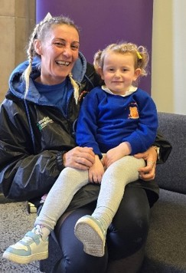
We’re thrilled to welcome Emily Johnson of Emily’s Miles of Smiles to our Welsh Champion Honours List!
Emily is celebrating 10 years in business this year, and what better way to mark the milestone than by becoming one of our incredible Welsh language ambassadors.
Based in Abertillery, Emily’s journey with Welsh began in January when she noticed more parents seeking Welsh-medium childcare. With passion and determination, she embraced the challenge—and hasn’t looked back!
“I’ve got an allotment and the older generation used to laugh when I started learning Welsh. Now they call me the Welsh lady and greet me with ‘Croeso’ or ‘Hwyl fawr’—I’ve even taught them a few words!”
Emily now works at Cylch Meithrin Brynithel, where she’s gaining confidence reading Welsh books to children and using everyday phrases. Her love of the language has even made family trips to North Wales more meaningful.
“I’m Welsh—I should be able to speak our language. I’m proud I’m learning, and I want to be fluent. That’s the plan!”
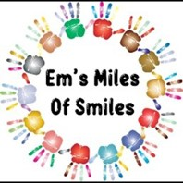
Emily began her journey with the Camau (learnwelsh.cymru/work-welsh/camau/) project via LearnWelsh.cymru and has jumped at every free course offered. Her advice? Give it a go. Keep going. It belongs to all of us.
Congratulations, Emily, on 10 years of inspiring young minds and for being a true champion of our language and culture.
Know someone making a difference with Welsh in your community? Nominate them by emailing Cymraeg@blaenau-gwent.gov.uk.
For more information and to get in touch with Emily follow this link: Emsmilesofsmiles - Facebook

