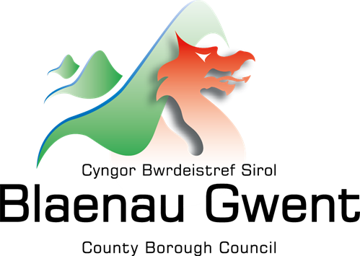

Blaenau Gwent County Borough Council

Welsh Language
Annual Report
April 2025 – March 2026

Prepared in accordance with the requirements of the Welsh Language Commissioner.

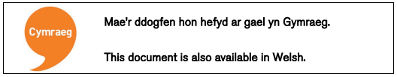

If you do require this document in a different format, e.g, large print, Braille, audio version, etc. please contact:

Email: pps@blaenau-gwent.gov.uk

Contents

Section | Title
1 | Introduction  - Regulatory framework  - Governance and accountability
2 | Meeting our Welsh Language Standards  2.1 Service delivery standards [1 - 87]  2.2 Policy making standards [88 – 97]  2.3 Operational standards [98 – 144]  2.4 Record keeping standards [147 – 154]
3 | Welsh Language Promotion Strategy 2022/27
4 | Welsh in Education Strategic Plan 2022/32
5 | Staff language skills
6 | Looking Forward

- Introduction

  - Regulatory framework
Blaenau Gwent County Borough Council presents its tenth Annual Report on Welsh Language Standards, providing a formal account of the Council’s ongoing responsibility to comply fully with the Welsh Language Standards as set out by Welsh Government and regulated by the Welsh Language Commissioner’s Office. This report sets out the key developments, improvements, and initiatives delivered over the past year to promote the Welsh language and its rich cultural heritage. In keeping with The Deal ethos, this work has been strengthened through collaborative engagement with a wide range of local partners and stakeholders, reflecting the Council’s commitment to working collectively to achieve meaningful and sustainable outcomes for communities.
This report has been prepared in line with the Welsh Language (Wales) Measure 2011 and covers the financial period from 1 April 2025 to 31 March 2026. The Measure provides the statutory framework governing the use of the Welsh language in the delivery of public services. In accordance with Standards 158, 164, and 170, all local authorities are required to publish an Annual Report setting out their compliance with service delivery, policy-making, and operational standards.
This report provides an evaluation of our ongoing efforts to create meaningful opportunities for the use of the Welsh language and to ensure that Welsh is treated no less favourably than English. Guided by The Blaenau Gwent ‘Deal’ ethos, we continue to place people at the heart of our services, supporting a bilingual environment that aim to enable individuals to engage with the Council confidently and effectively in the language of their choice.

  - Governance and accountability

Blaenau Gwent Council, as a public body, plays an important role in supporting and promoting the Welsh language. The Council is committed to meeting its Welsh Language Standards and being fair, open, and welcoming to all by working with and for our communities, as set out in the Corporate Plan 2022/27

The Corporate Plan 2022–2027 recognises the Welsh language as a key policy area that contributes to delivering our priorities, which focus on improving the well-being of local people and communities.

Business planning arrangements establish accountability across the organisation, ensuring that appropriate responsibilities are upheld in line with monitoring requirements. In addition, all staff are required to adhere to the Welsh Language Standards as part of the recruitment process, with this commitment further reinforced during induction.

Implementing the standards
All staff play a vital role in ensuring the organisation meets Welsh Language Standards while actively promoting and supporting the use of the Welsh language.

The Policy Team provide advice, guidance, and professional support across the organisation to help the Council uphold its Welsh language commitments and statutory obligations.

During this reporting period, significant progress has been made in enhancing the Council’s performance monitoring framework through business planning. Now, all directorates and service areas are required to submit quarterly updates detailing their compliance with Welsh Language Standards and the actions undertaken to support the objectives outlined in the Welsh Language Promotion Strategy 2022/27.

Political and Professional Leadership
Over the past year we have made real progress in strengthening our federated model with Torfaen County Borough Council. The Joint Chief Executive arrangement has developed into a more coordinated and collaborative approach, helping both councils share expertise, improve resilience and explore new ways of working together for the benefit of our communities.
We have also advanced work on the Blaenau Gwent Deal, a long‑term commitment to reducing inequalities by applying the Marmot Principles across local priorities, services and community partnerships. This year we have focused on building the evidence base, identifying priority areas for action and shaping how the Deal will support fairer outcomes across the county.
In doing so, the Deal is being aligned with our five missions:
- Early Years – Building Bright Futures: invest early, invest smart.
- Lifelong Learning and Resilience: skills are the new social contract.
- Wellbeing Through Community Leadership: health is created in communities, not hospitals.
- Thriving Economy and Vibrant Places: growth with purpose, not growth for its own sake.
- Empowered Communities – Shared Power and Success: from consumers of services to co-creators of change.
The missions seek to ensure that our approach to tackling inequalities is coherent, place‑based and centred on what matters most to people in Blaenau Gwent.

The Leader of the Council / Cabinet Member for Corporate Governance and Resources continue to hold portfolio responsibility for the Welsh Language. The Welsh Language Annual Report is considered by Corporate Governance and Resources Scrutiny Committee, Cabinet, and when appropriate the Council.

Welsh Language Compliance Group
Over the past year, the Welsh Language Compliance Group has continued to meet quarterly, bringing together representatives from departments across the organisation to oversee compliance with Welsh language requirements. During this time, the group has maintained oversight of policies, procedures, and progress against the promotion strategy, while addressing emerging compliance issues through standing agenda items such as the Welsh Language Forward Work Programme, internal monitoring, training updates, and examples of best practice.

Recognising the need to build on this foundation, the group is now seeking to further develop and review its approach, working collaboratively with Torfaen to establish a more consistent and cohesive model. This will support a more collective approach to compliance and help strengthen how we continue to progress within the federated model.
Education Transformation Team – Welsh in Education Strategic Plan
The Education Transformation Team undertakes monthly monitoring and review of the Welsh in Education Strategic Plan (WESP), providing termly updates to the Welsh in Education Forum (WEF) and an annual report to the Welsh Government.
In addition, annual development and progress reports relating to the WEF are submitted through the Council’s political processes. The WESP also remains a key priority for both the 21st Century Schools Programme Board and the Admissions Forum.
Alongside their work with the WEF, the Welsh Language Support Officer is an active member of the WEF Communications Sub Group, ensuring they remain well informed and can support the promotion of Welsh-medium education. The Officer also represents the Council on the Cymraeg i Bawb partnership group.
Cymraeg i Bawb is a national campaign to promote Welsh-medium education across Wales, led in south-east Wales by the South East Wales Welsh-medium Education Promotion Partnership. The partnership seeks to create a Wales where everyone has the opportunity to learn and use the Welsh language. It brings together Local Authorities, Mentrau Iaith, Cymraeg i Blant, RhAG, and the Welsh Government across the region.
Funded by the Welsh Government, with in-kind contributions from all partner organisations, Cymraeg i Bawb was established by Grŵp Deddf – South East Wales Welsh Officers. This initiative recognised that closer collaboration between organisations would enhance the collective impact of promoting Welsh-medium education.
The partnership values the strong Welsh-medium education provision available to children and young people, as well as the dedicated local staff who support parents and carers throughout their Welsh language journey.

- Meeting the Welsh Language Standards
Blaenau Gwent Council has been subject to the Welsh Language Standards Compliance Notice issued by the Welsh Language Commissioner since 2016. Responsibility for meeting these standards rests across the organisation, with all employees expected to treat Welsh equally with English and to give it due consideration. This expectation is clearly outlined in all job descriptions and reinforced during the induction process.
The Welsh language is embedded in the Council’s day-to-day operations. The information set out below provides selected examples from the past year, demonstrating how compliance with the Standards has been actively promoted and strengthened through service delivery, policy development, and operational practice.

Welsh Guidance Sessions
Welsh language guidance sessions continue to be delivered as part of the Welsh Language Forward Work Programme, with the aim of strengthening staff awareness and understanding of workplace compliance and increased Welsh language use. Facilitated by the Welsh Language Support Officer, these sessions are available both face to face and via Microsoft Teams. They cover a range of key topics, including:
- An overview of the Welsh Language Standards
- The Compliance Notice for Welsh Language Standards in Blaenau Gwent
- The Welsh in the Workplace Policy
- The Welsh Language Training Procedure
- Translation protocols
- Telephone communication guidelines
- Correspondence statements
- Document statement requirements
- Use of out-of-office templates
- Implementation of the Language Preference Form
- Use of language interpretation in Microsoft Teams meetings
The sessions actively promote the use of Welsh in the workplace in order to encourage increased staff participation. Through engagement with these sessions, employees develop valuable linguistic skills, enabling them to communicate with greater confidence and effectiveness in Welsh. This not only supports compliance with the Welsh Language Standards but also contributes to a more inclusive and culturally enriched working environment.
The sessions provide essential foundational training, including common greetings, everyday phrases, and service-specific terminology relevant to customer-facing roles. The scope of the training equips staff with practical linguistic skills to support effective professional communication. Sessions have been made accessible across all service areas, with additional tailored training available on request.
Furthermore, as an additional step, the Welsh Language Support Officer is currently undertaking team audits to assess existing Welsh language skill levels and service delivery capacity. This work will identify both areas of strength and areas requiring consideration as part of the ongoing development of the workforce.

  - Service Delivery Standards

A body's websites and on-line services [standards 52-57]
During this reporting period, the Council’s website has undergone a comprehensive review. This has provided an opportunity to update and significantly enhance the information available in relation to Welsh language regulations, promotion, and the use of Welsh across the borough.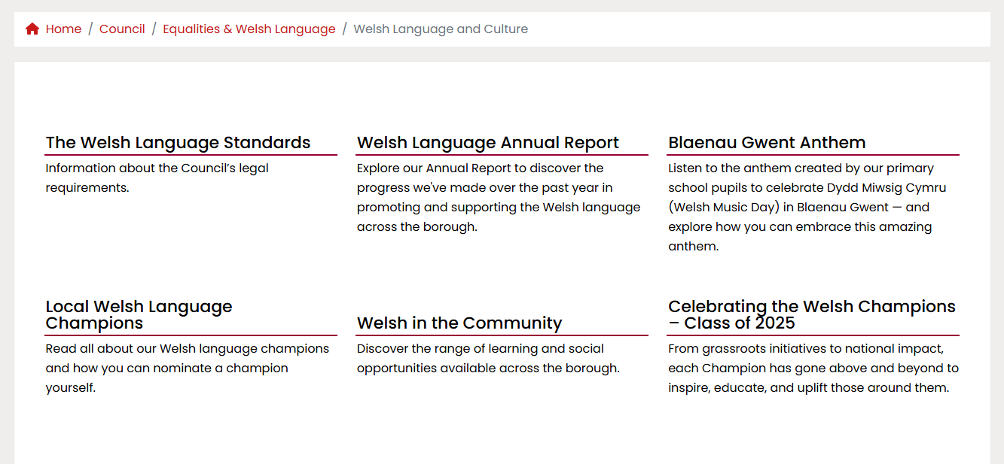
Previously, the website primarily contained statutory information required under the Standards relating to supplementary matters (Standards 155–176), such as the Annual Report, Compliance Notice, and 5-Year Promotion Strategy. The site has since been expanded and now includes a range of additional subsections, as outlined below:

Recruitment Portal
It was noted in last year’s Council Annual Report that the Welsh Language Officers were working with the Organisational Development Team to develop and integrate a new recruitment platform for the Council’s website. This portal has now been successfully implemented. The updated system delivers a significant improvement in compliance with Standards 52–57, as the previously separate Welsh and English recruitment platforms have been replaced by a single, fully integrated system. Users can now switch seamlessly between Welsh and English using a clearly visible language selection option within the website.
This development has also strengthened compliance with the application process, particularly in relation to Standard 137A. Under this standard, application forms, guidance materials relating to the recruitment process, and information about interviews and assessment methods must be available in Welsh and treated no less favourably than their English counterparts.
Previously, applicants wishing to apply in Welsh were required to locate and submit a separate Welsh-medium PDF expression of interest form. With the introduction of the new system and language selector, the entire application process is now accessible in Welsh, providing a more streamlined, consistent, and user-friendly experience.

Social Media
Standard 58: A body must not treat the Welsh language less favourably than the English language when using social media.
Following the publication of the Welsh Language Commissioner’s report on the compliance of social media accounts held by organisations subject to the Welsh Language Standards (No. 1 Regulations), a review of the Council’s social media presence was undertaken.
The review focused primarily on corporate identity, ensuring that all social media channel titles and biographies were presented bilingually. Where appropriate, profiles were also updated to include clear signposting to corresponding Welsh-language channels, such as through links or directions within account biographies (for example, on the Council’s Facebook profile).
Recommendation 1: Monitoring arrangements Organisations should review their self-regulation processes to ensure that all social media accounts across all platforms comply with the requirements of all relevant standards. It should be ensured that every member of staff who posts on social media and is responsible for the accounts used is fully aware of the standards’ requirements, through the provision of guidance and instructions on using Welsh on social media.
Recommendation 2: Corporate identity
Organisations should carry out a full audit of all social media accounts they are responsible for, to ensure that the Welsh language is not treated less favourably than English when presenting the organisation’s corporate identity. This includes checking logos, names, handles, and profile information.
Recommendation 3: Consistency when posting on social media
Organisations should ensure that, when publishing posts on social media, the whole content is available in Welsh —including the text, images, videos, and audio clips. It should also be ensured that the Welsh content is equally accessible and visible as the English content.
Recommendation 4: Promoting Welsh language accounts
Organisations should take steps to promote their Welsh-language accounts by including clear links from the corresponding English accounts to the Welsh accounts.
Recommendation 5: Videos
Organisations should explore alternative methods of publishing videos in Welsh, ensuring that the Welsh language is not treated less favourably than English within video content, where practically possible.

Standard 61: If a body erects a new sign or renews a sign (including temporary signs), it must ensure that any text on that sign is in Welsh. A body may display the Welsh language text either on the same sign with the corresponding English language text or on a separate sign. A body must ensure that it does not treat the Welsh language text less favourably than the English language text on such signs
The Council’s principal workplace, the General Offices in Ebbw Vale, is currently undergoing substantial refurbishment to increase the availability of office accommodation, reflecting a shift towards more office-based working.
As part of this redevelopment, the reception area has been relocated to improve accessibility, strengthen safety and security arrangements, and enhance its visibility to visitors. These changes are designed to provide a more welcoming, functional, and inclusive environment for both staff and members of the public.
In line with the refurbishment and reconfiguration of facilities, new signage has been installed throughout the building. The Welsh Policy Team has supported this work to ensure that all signage is fully compliant with the Welsh Language Standards, with Welsh given equal prominence to English in both workplace and public-facing areas.

Standard 22: A body must ensure that any automated telephone systems that it has provides the complete automated service in Welsh
The Welsh Language Policy Officer has continued to support the Shared Recourses Service and Contact Centre in recording all amendments to automated voicemails and IVR’s (Interactive Voice Response Systems) to ensure accuracy and consistency.

Standard 81: A body must promote and advertise any Welsh language service that it provides and do so in Welsh.
We remain committed to encouraging residents to engage with our services in Welsh, building on the success of last year’s Whichever way… campaign:
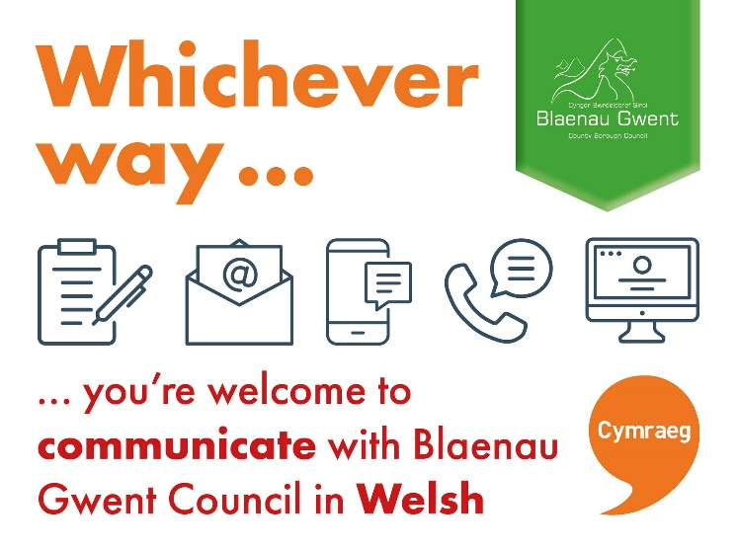
Our Welsh Language Support Officer works with our Welsh Language Champion Network to help promote and support the use of council services in Welsh. We recognise that, due to the low number of Welsh language users within the borough, engagement with council services through the medium of Welsh is currently very limited. In response, we use all available platforms to promote our Welsh-language services. This approach also provides staff with increased opportunities to practise using Welsh at their own level, or to familiarise themselves with the processes in place for arranging Welsh-language support, including locating a Welsh speaker to assist with service delivery in Welsh.

2.2 Policy Making Standards

Standards 95-97
These standards are a way of ensuring that any research a body undertakes when making a policy decision, considers and deals with the effect that decision will have on the Welsh language and on the opportunities to use it

An Integrated Impact Assessment (IIA) module for the Council’s online training platform, Thinqi has been drafted. The IIA is a corporate assessment tool used across BGCBC to evaluate the potential impacts of decisions, policies, and services against a range of key considerations, including the Equality Act 2010, the Well-being of Future Generations (Wales) Act 2015, the Corporate Plan, and other relevant frameworks.
Within Blaenau Gwent, the Welsh Language (Wales) Measure 2011 is incorporated into the IIA under Section 5. While general guidance and support are available to all staff when completing these assessments, IIA training is also embedded within the Welsh Language Support Officer’s wider Welsh language guidance programme, which is currently being rolled out across the organisation.
The Thinqi IIA module is scheduled for formal launch later this year. Participation data will therefore be collected and reported in the next annual report.

Translation Policy Agreement for Democratic Services
Our Democratic Services team routinely arranges translation of reports, agendas, and minutes for Corporate and Performance Overview Scrutiny and Council meetings, ensuring these documents are available to the public via the Council’s website.
To support timely publication, a specific agreement has been established (taking into account the exceptions outlined in our Compliance Notice) to streamline the translation process. This arrangement allows the standard procedure to be adapted, removing the requirement to approach all approved translators for each piece of work. Instead, a designated primary translator, supported by an identified secondary (back-up) translator, has been appointed to undertake this work on a regular basis.
This approach was adopted to provide a consistent and reliable service, ensuring compliance with Standard 41. The arrangement will be kept under review, and any necessary changes will be made in accordance with the Welsh Language Standards and the Council’s procurement processes.

  - Operational Standards

Training
Standard 130: A body must provide opportunities during working hours
- for its employees to receive basic Welsh language lessons, and
- for employees who manage others to receive training on using the Welsh language in their role as managers.

Standard 131: A body must provide opportunities for employees who have completed basic Welsh language training to receive further training free of charge, to develop their language skills.

Standard 132: A body must provide employees with training in the following areas:
- Awareness of the Welsh language.
- An understanding of the duty to operate in accordance with the Welsh language standards.
- An understanding of how the Welsh language can be used in the workplace.

Dysgu Cymraeg | Learn Welsh
The Council continues to promote and support Welsh language learning for staff through its training provider, Dysgu Cymraeg. Staff are encouraged to engage with Welsh language training at a level appropriate to their role and confidence, including self-study online modules and tutor-led courses.

During this reporting period, four members of staff enrolled on online Mynediad 1 courses. In addition, one member of staff progressed to a Mynediad 2 course, demonstrating continued development in Welsh language skills.
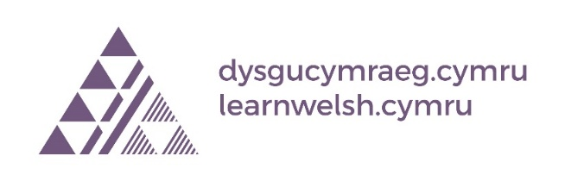
Information on upcoming courses, and general online self study courses provided by Dysgu Cymraeg, are regularly communicated to staff through internal newsletters and managers’ briefings. These communication channels help to promote ongoing engagement with Welsh language learning across the organisation and support compliance with Welsh Language Standards.

During this reporting period 42 members of staff have completed 1 or more online training units.
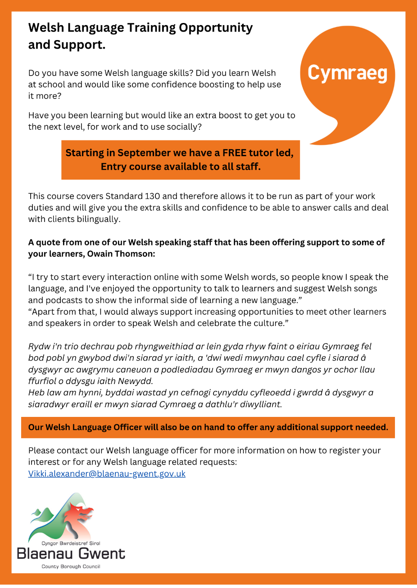

Support Sessions for Staff
The Council’s lunchtime Welsh sessions, led by the dedicated and enthusiastic Welsh Language Support Officer, have been rebranded as ‘Clwb Clonc’. These sessions are held on the last Wednesday of each month.
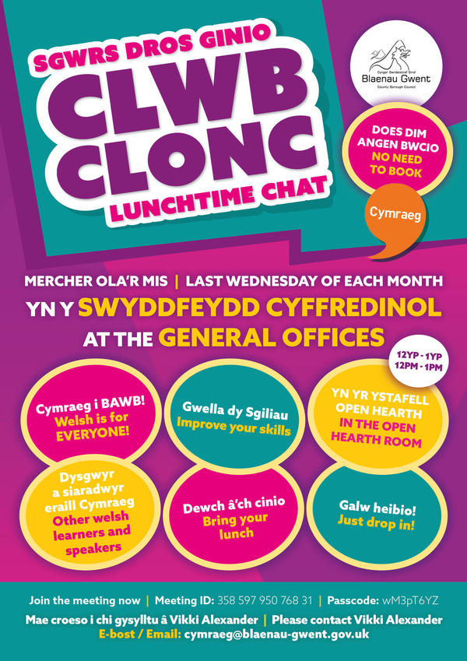

These sessions demonstrate a strong commitment to supporting the Welsh language, ensuring that all learners are aware of the assistance available to them. This includes responding to queries, providing practical guidance, and recommending effective ways to engage with the language.
Support sessions are delivered monthly on a rotating basis, alternating between online and face-to-face formats. Open to staff of all linguistic abilities, they offer a structured, supportive, and inclusive environment for everyone.

Online Staff Training - Thinqi
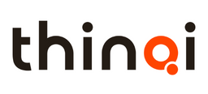
All staff are required to complete the Welsh Language Awareness Module as part of their essential learning programme. This is a mandatory module and must be renewed every three years.

As of 31 March 2026, 1994 members of staff (65.6%) had completed the module, representing a significant increase from 40% in the previous year. While this demonstrates strong progress, it is recognised that a significant proportion of the workforce is not desk-based, which can impact accessibility and contribute to challenges in achieving full (100%) compliance.

To address this, work is ongoing to improve completion rates through targeted promotion and regular monitoring. A dedicated plan will also be developed during the next reporting cycle to better engage and support non-desk-based staff in accessing and completing the module.

Welsh Language Awareness as at 31.03.2026
Directorate | % of Staff
Adults & Communities | 86.5%
Children, Young People & Families | 59.5%
Corporate Services | 89.1%
Economy and Place | 81.1%
Neighbourhood and Environment | 54.1%
Total BG Compliance | 65.6%

Jobs Advertised

Standard 136 If a body assesses the requirements for a new or vacant post, it must assess the need for Welsh language skills, and categorise it as a post where one or more of the following apply:
- Welsh language skills are essential
- Welsh language skills need to be learnt when appointed to the post
- Welsh language skills are desirable
- Welsh language skills are not necessary.

During this reporting period, 270 roles were advertised; however, none were identified as requiring Welsh language skills as essential. This is a disappointing position and highlights the need to review and strengthen our recruitment processes.

In particular, greater emphasis is needed on the effective use of the Recruitment Authorisation Form, ensuring that recruiting managers properly assess their team’s Welsh language capacity and consider where Welsh language skills should be designated as essential. This is where the current offer of resilience assessments, delivered by the Welsh Language Support Officer, plays a crucial role in supporting managers to understand existing capacity, identify gaps, and make more informed decisions about Welsh language requirements within their teams.

As a result, we will review both the use of the Recruitment Authorisation Form and its implementation across the organisation, to support more robust and consistent decision-making in relation to Welsh language requirements.

  - Record keeping standards [147 – 154]

Standard 147: A body must keep a record, in relation to each financial year, of the number of complaints it receives relating to its compliance with the standards.

During this reporting period, we are pleased to report that no complaints or investigations were initiated against Blaenau Gwent in relation to its compliance with the Welsh Language Standards.

However, in March 2026, a Freedom of Information (FOI) request was received concerning the local authority’s capacity to deliver swimming lessons through the medium of Welsh. Swimming lessons within Blaenau Gwent are delivered by the Aneurin Leisure Trust, and to date no requests have been received for lessons to be provided in Welsh.

The response issued by the Aneurin Leisure Trust subsequently led the organisation that submitted the FOI request to raise concerns with the Council regarding its compliance with the Welsh Language Standards outlined below:

Standard 84: If a body offers an education course that is open to the public, it must offer that course in Welsh.

Standard 85: If a body offers an education course that is open to the public, and which is aimed specifically at persons aged 18 or under, it must offer that course in Welsh. For example, this may include education courses aimed at primary or secondary pupils.

All surrounding authorities also received this FOI request and have had a similar outcome regarding concerns surrounding their ability to provide Welsh language swimming lesson. A further update on how this progresses will be provided in our next annual report.
- Welsh Language Promotion Strategy 2022/27

All local authorities in Wales are required to have a five-year promotion strategy setting out how they will increase the visibility of the Welsh language and create opportunities for engagement with both the language and its culture. Our current strategy aligns with the Welsh Government’s ambitious target of reaching one million Welsh speakers by 2050. Blaenau Gwent Council is now in the final year of its current strategy, and work to develop and consult on the next strategy (2027–2032) will begin in the second half of this year.
The information below provides a snapshot of key activities undertaken during this reporting period that support delivery against the objectives of the current promotion strategy.
Since 2024, the Policy Team has successfully secured Shared Prosperity Funding to support employment-related costs and enable the continued role of the Welsh Language Support Officer within the Council. As a result, all costs associated with the work outlined below have been met through this funding.
This funding has significantly strengthened the Policy Team’s capacity to deliver the objectives of the Welsh Language Promotion Strategy. A key element of this work is the communications plan, which underpins efforts to promote the value, richness, and visibility of the Welsh language and its culture across the organisation, with the public, and within educational settings.
The Welsh celebrations and traditions calendar forms an integral part of this approach and is outlined below

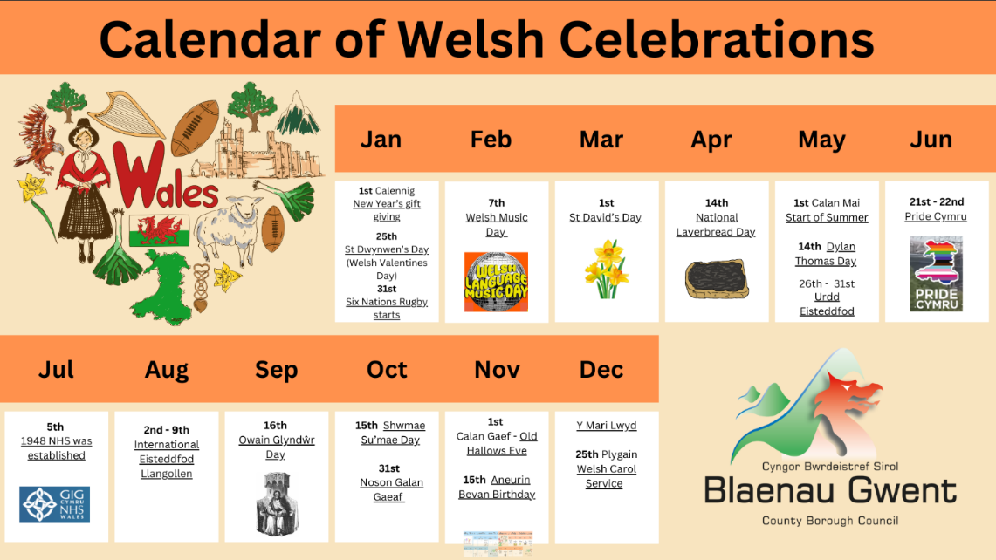

Dydd Gŵyl Dewi Local Council Funding

It is recognised that local town and community councils often organise St David’s Day events within their respective areas. In response, the Council provided support this year through grant funding. Up to £1,000 was made available to each council from the Shared Prosperity Fund to deliver events and activities marking this culturally significant occasion.
Applications were received from three of the four councils—Brynmawr Town Council, Tredegar Town Council, and Abertillery and Llanhilleth Town and Community Council.
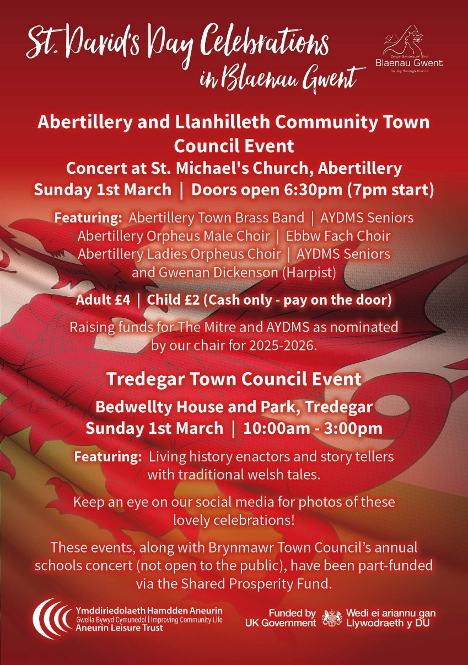
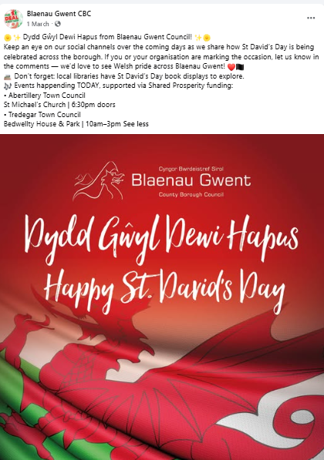

Brynmawr Town Council Schools Concert
Brynmawr Town Council once again delivered a vibrant and inclusive cultural event at the Market Hall Cinema, building on the success of the previous year. The event brought together local primary schools, musicians, and performers to celebrate and promote the Welsh language and heritage. It provided a valuable platform for young people to engage with Welsh culture, with pupils from local primary schools giving enthusiastic performances alongside talented local musicians and a harpist.
A particular highlight was the appearance of the popular Draig Dewi character, which added an enjoyable and memorable element for children and attendees alike. The combination of music, performance, and cultural storytelling created an engaging atmosphere that helped foster pride in the Welsh language among younger generations.
The event demonstrated the Town Council’s ongoing commitment to supporting cultural initiatives and encouraging early engagement with Welsh identity. By creating opportunities for children to participate in and experience the richness of Welsh traditions, this annual event continues to play an important role in strengthening community cohesion and promoting a sense of cultural belonging.
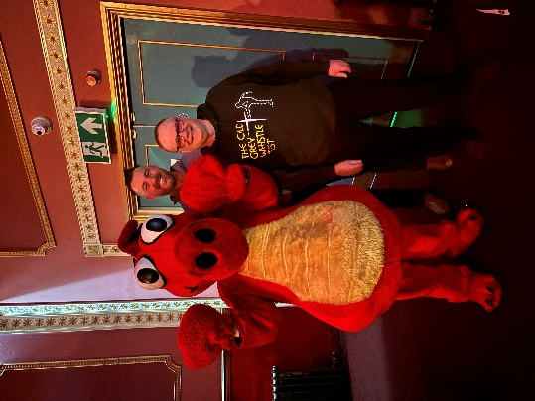
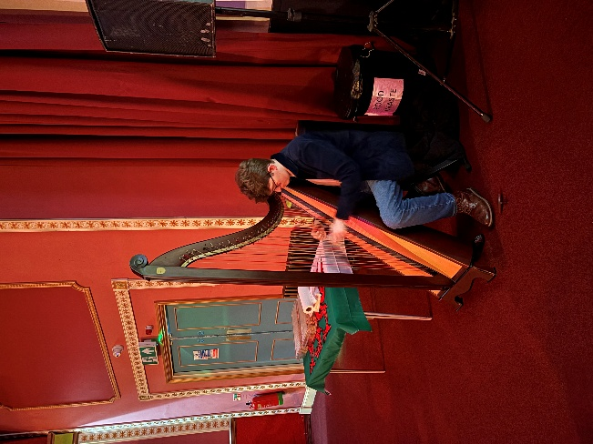
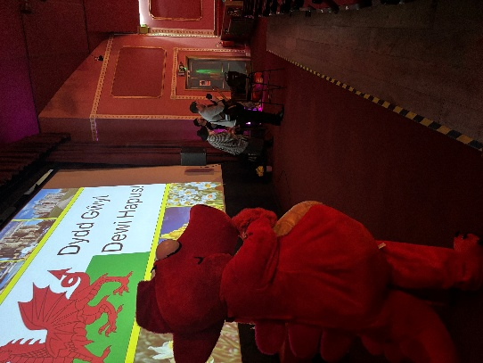

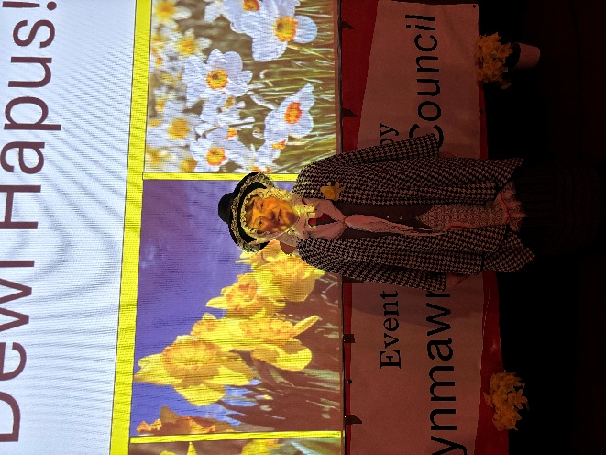

Tredegar Town Council

Tredegar Town Council utilised the funding to deliver two successful and engaging cultural events at Bedwellty House and Park—one open to the wider community and another specifically for local schools. Both events offered immersive experiences centred on Welsh language, history, and heritage.

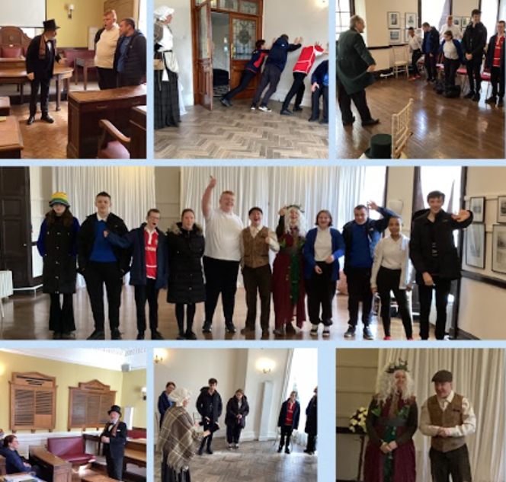

The programme included traditional historical re-enactments, folk storytelling, live music, and hands-on craft activities, providing participants with an engaging and interactive way to experience Welsh culture. The dedicated schools event enabled young learners to explore these elements in a more focused setting, helping to build early interest, confidence, and connection with Welsh identity and language.
To extend the impact beyond the events, local schools were also provided with a selection of Welsh language and Welsh history books, supporting continued engagement with Welsh culture throughout the academic year.
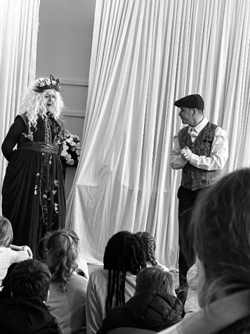
These activities demonstrate a strong commitment to making the Welsh language visible, accessible, and enjoyable for both residents and younger generations. The events support key priorities within the Blaenau Gwent Welsh Language Promotion Strategy by increasing opportunities to use Welsh socially within the community, encouraging engagement among children and young people through targeted school activities, and raising awareness of Welsh language and heritage through cultural performances and storytelling.
Furthermore, the provision of Welsh-language resources to schools ensures longer-term benefits by promoting ongoing use and familiarity with the language. Strong collaboration with local schools and community partners has also helped embed Welsh language promotion at a local level, supporting a more sustainable, community-led approach to strengthening the use of Welsh across Blaenau Gwent.

Abertillery and Llanhilleth Town and Community Council

Abertillery and Llanhilleth Town and Community Council delivered a special St Davids Day concert bringing together a myriad of local singers and performers to celebrate this important day within Welsh culture.

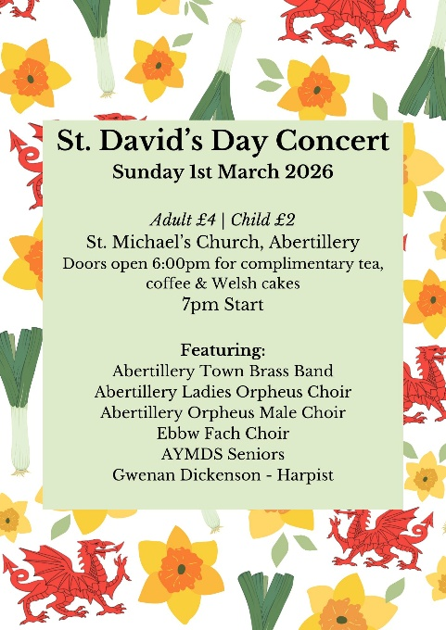

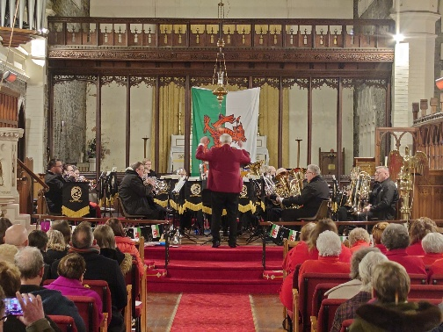
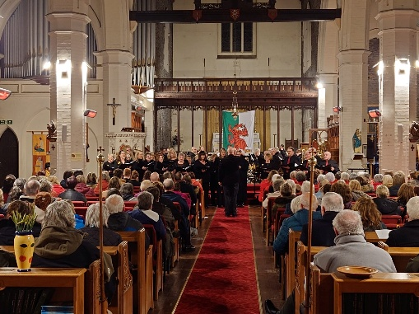

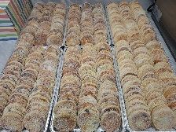
Laverbread Day
This year we decided to use National Laverbread Day to highlight the amazing work our Food Partnership do for the community. We also shared recipes and encourages our local cooking projects and schools to get involved by creating some of their own dishes using this Welsh delicacy.

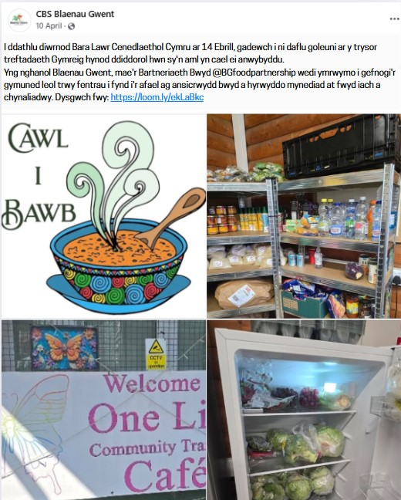
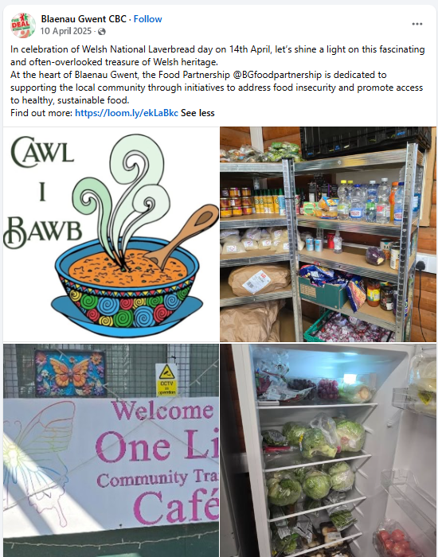

Dylan Thomas Day
To mark Dylan Thomas Day, the Council worked in partnership with local libraries to celebrate the life and legacy of one of Wales’s most iconic literary figures.
An engaging creative writing workshop was delivered, providing participants with the opportunity to explore their creativity while drawing inspiration from Dylan Thomas’s distinctive style and powerful use of language. The session encouraged experimentation with both poetry and prose, helping to build confidence and foster an appreciation for creative expression.
In addition, a special open mic night was supported and promoted at The Met in Abertillery, offering members of the community the opportunity to share their own work in a welcoming and supportive environment. The event brought people together to celebrate storytelling, poetry, and performance, reflecting Dylan Thomas’s lasting influence on the literary world.
These activities not only honoured Dylan Thomas’s legacy but also highlighted the importance of nurturing creativity and promoting literature within local communities. Appreciation is extended to all those who took part and contributed to the success of the celebrations.

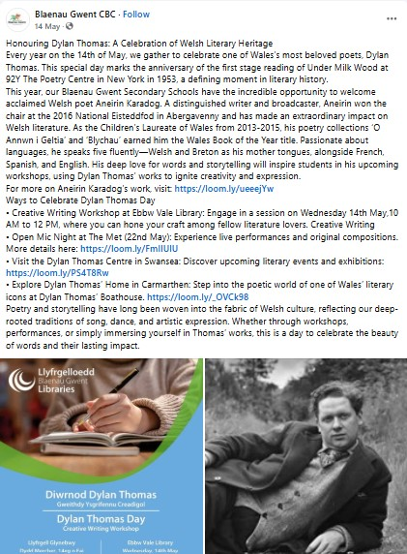

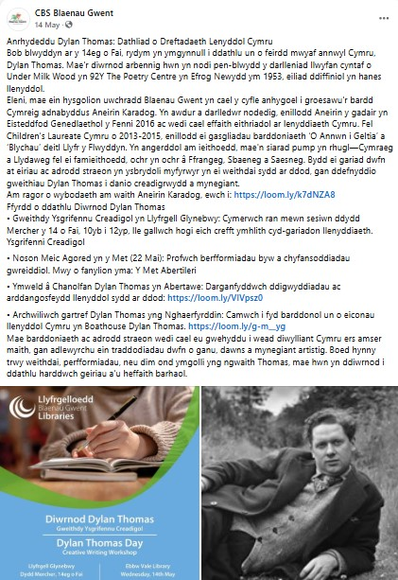

Primary and secondary schools were also offered the opportunity to participate in workshops delivered by Alex Wharton and Aneirin Karadog, providing learners with creative experiences inspired by the work and legacy of Dylan Thomas.

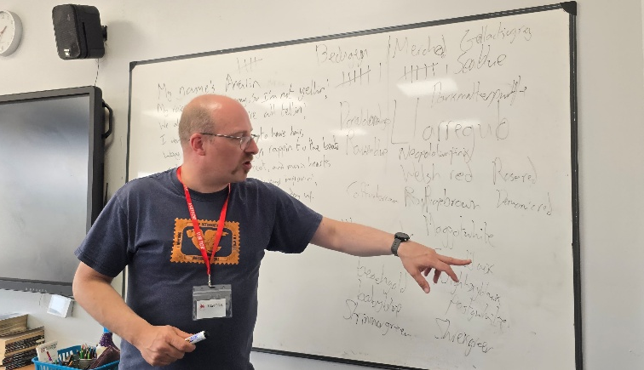
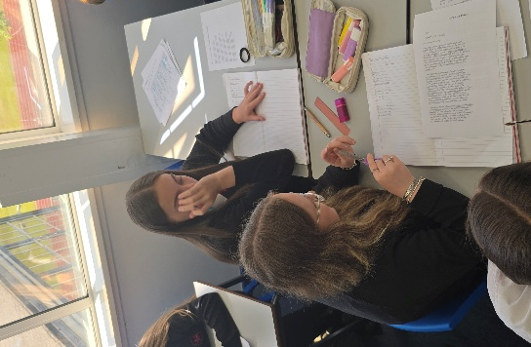

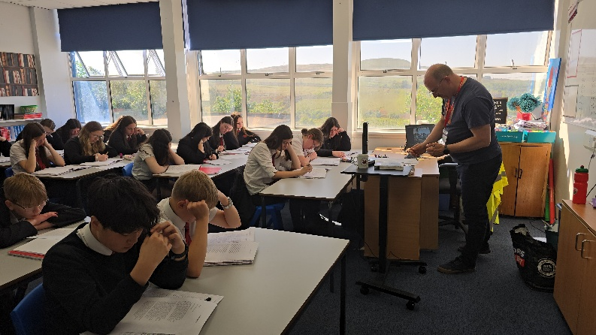
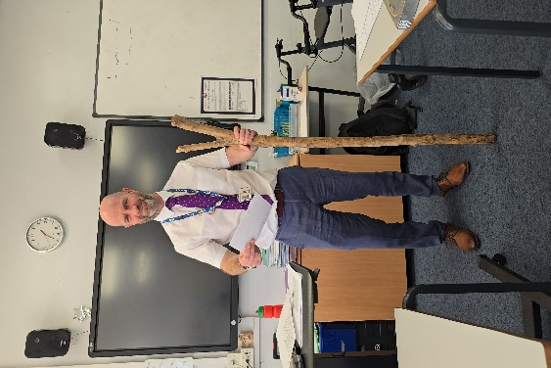

Pride Cymru Parade

As part of the council’s ongoing commitment to strengthening equality, we are part of the Proud Councils Network a UK-wide network of local authorities that work together to support and promote LGBTQ+ inclusion within councils and the communities they serve.
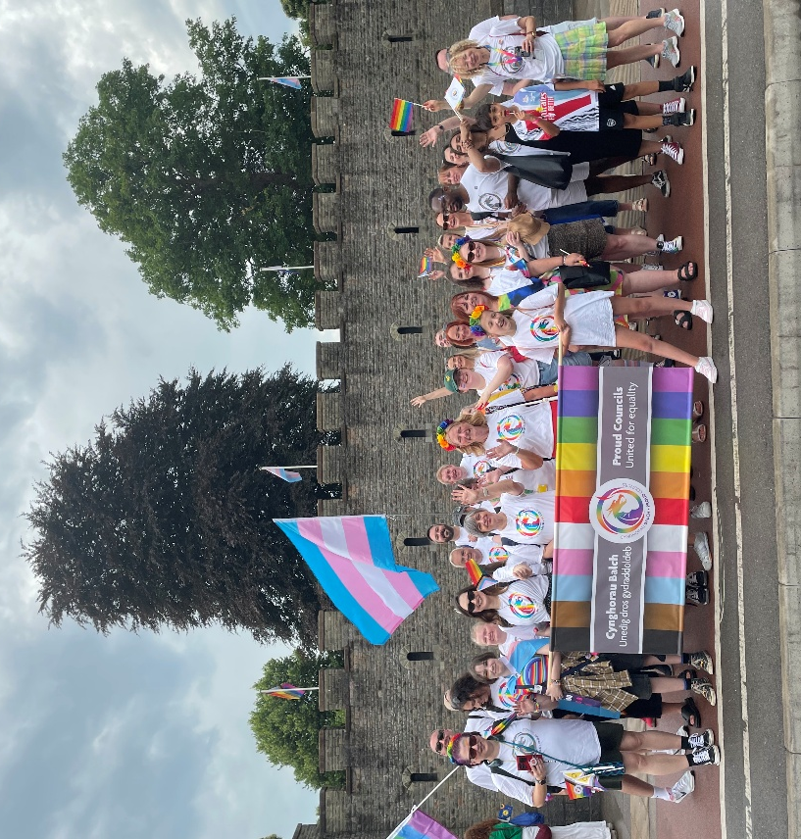
Membership of the network demonstrates a council’s commitment to creating safe, inclusive, and welcoming environments for LGBTQ+ employees and residents. Councils involved in the network collaborate to share good practice, develop inclusive policies, and improve services so they better meet the needs of LGBTQ+ people.
We were pleased to be able to send our Welsh Language Support Officer to march alongside colleagues from neighbouring councils at Pride Cymru this year. Many of the equality officers within these authorities also hold Welsh language–related roles and are Welsh speakers, making this a valuable opportunity to strengthen professional relationships and collaborate as Welsh language officers in a shared, inclusive space. Pride Cymru plays a vital role in contemporary Welsh culture by celebrating diversity, promoting equality, and strengthening the visibility of LGBTQ+ communities across Wales. It provides an inclusive environment where people can express their identities openly, while highlighting the importance of respect, acceptance, and human rights—values that are central to modern Welsh society. As a nationally recognised event, it brings together communities from across Wales, including Welsh speakers, and supports the use of the Welsh language in inclusive settings, reinforcing its relevance in all aspects of civic life. By combining cultural celebration with social awareness, Pride Cymru reflects Wales’s commitment to equality and contributes to a more open, confident, and culturally rich nation.
Diwrnod Su’mae Shwmae

For the past year we have been working on a new project our ‘Welsh Language Champions’; have been asking the community to nominate passionate individuals who go above and beyond to promote and celebrate the Welsh language in their communities, workplaces, or schools. Whether they’re encouraging others to use Welsh in everyday life, organising events, or simply leading by example. We have been celebrating how these incredible individuals play a vital role in keeping the language alive and thriving. All those who have been nominated have sat down with our Welsh Language Support Officer to share their experiences which in turn has been shared on both internal and external platforms to encourage and inspire others to engage with the Welsh language. As noted above this ‘The Welsh Language Champions’ has become a section on the councils’ website that is continuing to grow as more and more incredible people are being brought to our attention.

With a mix of lifelong fluent speakers, to newly learnt and currently learning we thought Su’mae Shwmae Day was the perfect opportunity to celebrate this years’ champions.
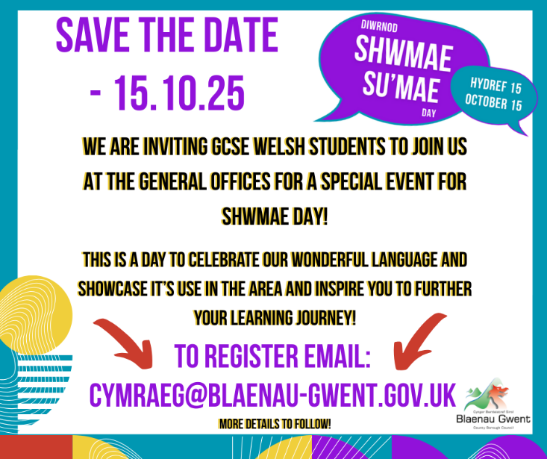
GCSE students along with our Welsh Language Champions and staff learners were invited to the General Offices where special guests S4C presenter Gabriella Jukes and rugby star / S4C presenter / rapper Lloyd Lewis, who shared inspiring stories of identity, inclusion, and the role Welsh plays in their lives and careers. All of which was broadcasted live on our social media for those at home to tune into.
Our champions were then presented with their certificates and given the opportunity to share some words of wisdom. We had a whiteboard created especially for this event that we think will be a fabulous reusable resource moving forward; those in attendance had the opportunity to fill in the white board we had created by a local company with their favourite Welsh words.

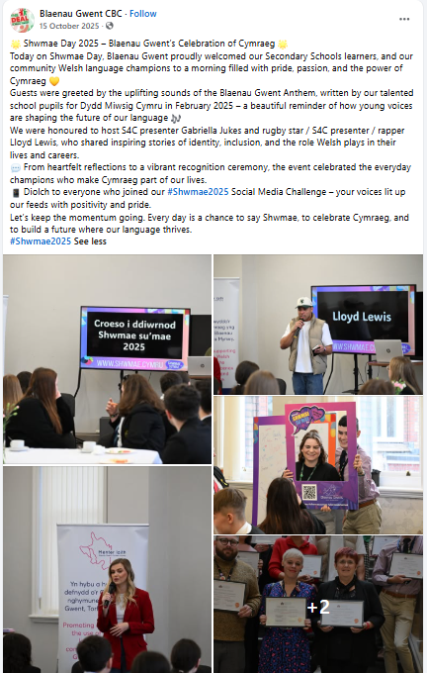
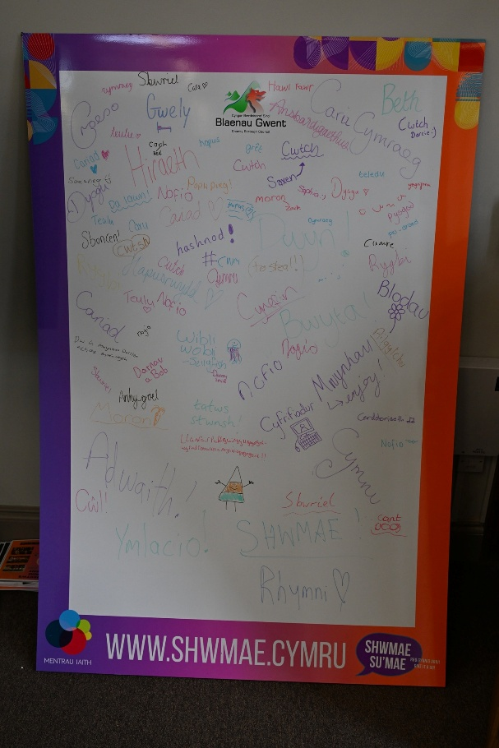
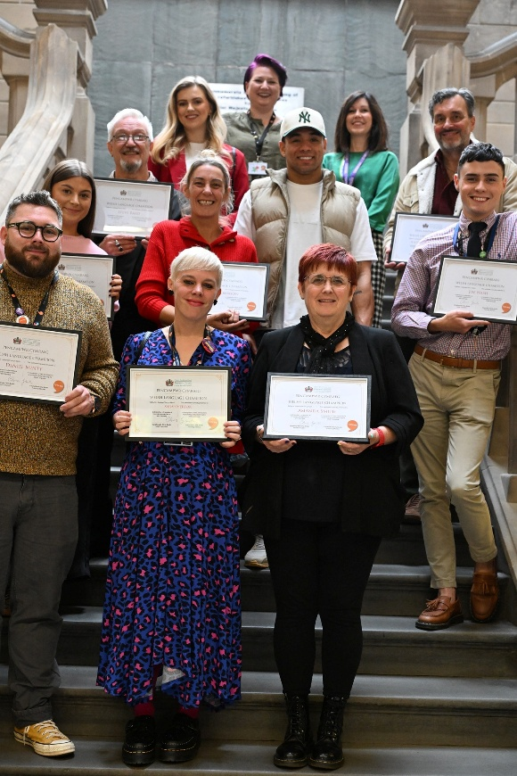

Business Promotion
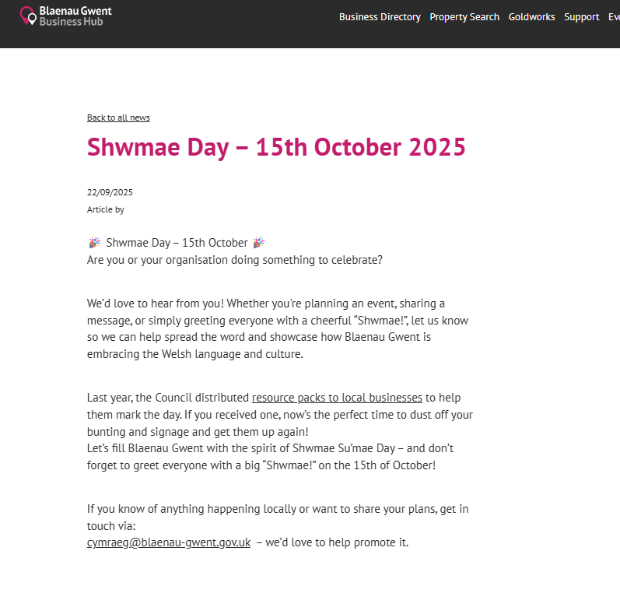
Momentum from the previous year’s campaign was maintained throughout this reporting period. Business support packs, developed to encourage and support the use of Welsh across a range of workplace settings, continued to be actively promoted. Targeted reminders were issued to businesses that had previously engaged with the initiative, encouraging them to revisit and make use of the available resources.
In addition, Shwmae Day was featured as a key event on the Blaenau Gwent Business Hub website, reinforcing opportunities for businesses to engage with and promote the Welsh language.

School Involvement

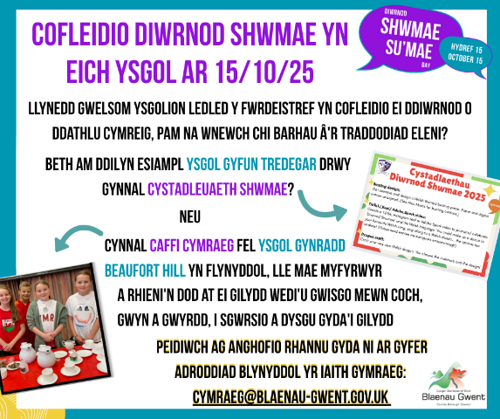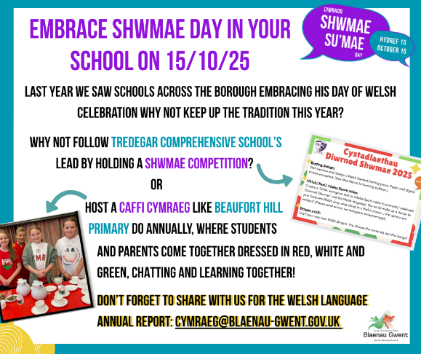
As part of ongoing engagement, all schools were issued with reminders to participate. Examples of effective practice already undertaken by schools were also highlighted, with the aim of inspiring and encouraging others to adopt similar approaches.

Welsh Rarebit Day

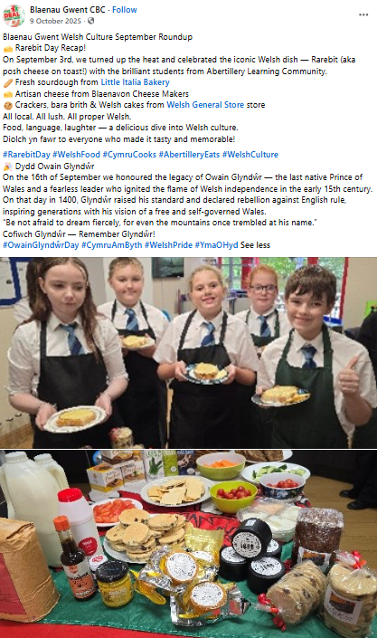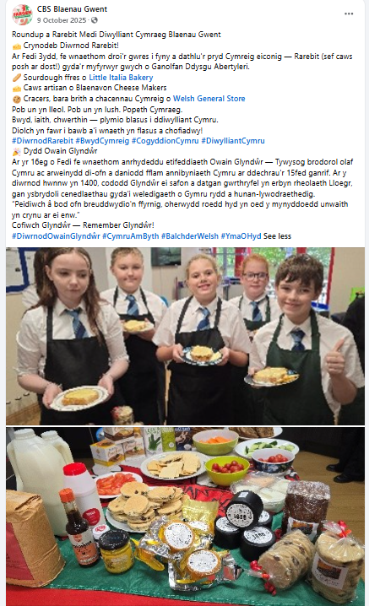

Partnership working with Abertillery Learning Community enabled the delivery of a bilingual cooking session. All ingredients were locally sourced, and learners prepared traditional Welsh rarebit while exploring its history and cultural significance through a range of engaging activities.
The Welsh language was embedded throughout the session, with learners encouraged to use Welsh when naming ingredients and following instructions, which were delivered bilingually. This approach supported meaningful and practical use of the language in an informal and enjoyable setting.
This activity directly supports Action 2.4 of the Welsh Language Promotion Strategy by providing an extra-curricular bilingual opportunity and creating a social environment in which children and young people from both Welsh-medium and English-medium schools can engage with and use the Welsh language.

- Welsh in Education Strategic Plan 2022/32

The Education Resources & Planning Team
The Education Resources & Planning Team review and monitor the Welsh in Education Strategic Plan (WESP) monthly; providing termly reports to the Welsh in Education Forum (WEF) and an annual report to Welsh Government. In addition, WEF development and progress reports are taken via the Council’s political processes annually. The Welsh in Education Strategic Plan is also a key focus of the Sustainable Communities for Learning Programme Board and Admissions Forum.

WESP
- Ysgol Gymraeg Tredegar opened in September 2023 in a temporary location at Ty Bedwellty for Nursery and Reception pupils. In September 2024, pupil numbers increased. The new school building was completed, and in November 2025 pupils moved to the Chartist Way site. Numbers remain positive, with 65 pupils currently on roll. As of April 2026, this includes 39 Nursery pupils, 13 in Reception, 8 in Year 1 and 5 in Year 2.

- Admissions to Ysgol Gymraeg Bro Helyg have also increased in the Nursery and Reception classes for the 2025/26 academic year. As of April 2026, there are 58 pupils in Nursery, 48 in Reception, 46 in Year 1, 34 in Year 2, 43 in Year 3, 36 in Year 4, 31 in Year 5 and 31 in Year 6. The school is therefore forecasting a sufficiency position soon, and additional capacity will be needed.

- As noted above, Blaenau Gwent successfully delivered Ysgol Gymraeg Tredegar in Sirhowy, a 210-place Welsh-medium primary school, through the Welsh Medium Capital Grant. The school currently falls under the governance arrangements of Ysgol Gymraeg Bro Helyg. The private childcare facility at Chartist Way in the Tredegar/Sirhowy Valley is currently being retendered by the Childcare Team. Welsh Government has since released a new Capital Grant, and Blaenau Gwent has submitted an expression of interest to support a small four-classroom extension at Ysgol Gymraeg Bro Helyg to address forecast capacity issues. In addition, a bid has been submitted to transfer a school along the continuum from English-medium to Welsh-medium education provision.

- A commitment has been given as part of the WESP 10-year plan to undertake a feasibility study to determine where there is a need for further provision and map that accordingly across Blaenau Gwent.

Welsh Medium Secondary Planning

A Welsh Government regional group has been established to review Welsh-medium secondary provision across the South-East region. Blaenau Gwent is part of this regional planning work alongside Monmouthshire, Powys and Torfaen, with discussions focusing on learner demand, transition trends, forecast pupil numbers and future capacity. The group continues to monitor projections and place-planning requirements to inform longer-term options for Welsh-medium secondary education. Earlier concerns suggested that Ysgol Gymraeg Gwynllyw may reach capacity by 2028; however, updated modelling now indicates that the school is likely to be able to accommodate Blaenau Gwent learners until at least 2032.

Blaenau Gwent Council has developed a strong marketing and communications plan to promote the benefits of bilingualism. The Council has also established appropriate methods of engagement and consultation with stakeholders to help inform key strategic priorities.

The Welsh in Education Forum meets termly to discuss progress against the objectives set out in the Welsh in Education Strategic Plan. Monitoring groups also continue to operate proactively. The Communications Sub-Group, which includes key partners, education officers and council officers, has continued to meet bi-monthly, with membership increasing over the course of the year. The group works collectively to share upcoming events and resources that support the delivery of the WESP objectives, and to develop communication materials that promote Welsh in education and the opportunities available in Blaenau Gwent.

In general sabbatical Welsh figures continue to increase annually with school staff uptake of courses increasing year on year, however it is noted that in the academic year 2025/26 there were no members of Blaenau Gwent accessing this opportunity.

Immersion Grant
Welsh Government provided the local authority with funding to develop an immersion unit at Ysgol Gymraeg Bro Helyg to support late entrants to Welsh-medium education. There have been three rounds of pilot funding: 2021/22, 2022/25 and 2025/26.

To support delivery of the project, the Council works closely with neighbouring authorities to compare models of immersion provision, identify and address any gaps, and develop best practice. In addition, the project has helped to shape the communications and promotion plan, working in partnership with the Blaenau Gwent Welsh in Education Forum, and has supported implementation of the new provision in line with the Blaenau Gwent Welsh in Education Strategic Plan. Going forward, this provision will also be used to support learners wishing to transfer to Ysgol Gymraeg Tredegar.

Please see the video created in partnership with Rhieni dros Addysg Gymraeg (Parents for Welsh Education), which provides a real-life insight into the success of the immersion unit and showcases the facilities available.

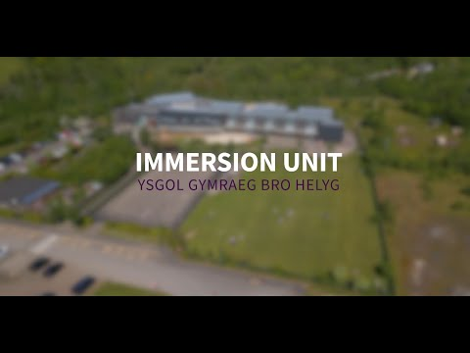
https://www.youtube.com/watch?v=A6pWTphOwvw

Additional Learning Needs
As part of the Local Authority Resource Base review and the Additional Learning Needs consultation in 2022, a Special Needs Resource Base (SNRB) for up to 10 pupils with ALN was established at Ysgol Gymraeg Bro Helyg Primary School from September 2024. A classroom was remodelled to create the resource base, including a sensory room, a calming room and access to outdoor space to support learners.

During the reporting period, new members of staff were recruited to Canolfan y Noddfa, the autism spectrum disorder (ASD) centre at Ysgol Gymraeg Bro Helyg. The unit currently supports eight learners.

- Welsh Language Skills
Standard 127
A body must assess the Welsh language skills of its employees
Under Standard 127, all local authorities in Wales are required to maintain an accurate and up-to-date record of their employees’ Welsh language skills. Within Blaenau Gwent Council, this information is collected and managed through iTrent, the Council’s workforce database. Regular reminders are issued throughout the year to encourage staff to review and update their records. Maintaining this data is essential to support workforce planning, identify areas of capacity and need, and ensure the Council can meet its Welsh language obligations in service delivery.
As of 31st March 2025, the Council employed 3,039 staff. It should be noted that figures relating to staff members’ main language and their Welsh language proficiency do not align precisely. This is due to the way information is recorded within iTrent, which allows individuals to select more than one main language. In addition, Welsh language skills are recorded against specific roles rather than individual employees, meaning that staff who hold multiple roles within the authority may be counted more than once.
Changes to the Organisation’s Structure
Since the previous reporting period, the Council’s directorate structure has undergone significant change. A new Children, Young People and Families directorate has been established, bringing together Education, Children’s Social Services, and the Youth Service. In parallel, Adult Social Services has been realigned within a separate Adults and Communities directorate.
The former Regeneration and Community Services directorate has been disbanded, with its functions redistributed across the Neighbourhoods and Environment and the Economy and Place directorates.
As a result of these organisational changes, direct like-for-like comparisons between this year’s and last year’s Welsh language skills data are not possible.

Directorate | Teams
Children, Young People and Families | Children’s Social Services  Education  Youth Service
Corporate Services | Finance and Resources  Legal and Compliance  HR / OD  Governance and Assurance
Adult and Communities | Adult Social Services  Communities
Neighbourhood and Environment | Public Protection  Neighbourhoods  Infrastructure
Economy and Place | Planning  Placemaking  Regeneration

In 2025, the Education directorate recorded the highest overall number of staff with Welsh language skills and demonstrated a broader distribution across intermediate to fluent levels compared to other areas. In contrast, directorates such as Corporate Services and Regeneration and Community Services showed limited higher-level capability, while Social Services had a small number of Welsh speakers but remained largely concentrated at lower skill levels.
By 2026, the newly formed Children, Young People and Families directorate—now the largest workforce area—reflects a similar pattern to the former Education directorate, with comparatively higher numbers of staff at intermediate, advanced, and fluent levels. However, the majority of staff in this directorate, as with others, are still recorded at no ability or entry level. Directorates such as Economy and Place, and Neighbourhoods and Environment, continue to show very limited Welsh language skills beyond basic levels.
Overall, the data indicates that across all services, most staff report either no Welsh language ability or only entry-level skills, with relatively few at advanced or fluent levels. This trend is consistent across Welsh reading and writing skills, as reflected in the charts below.

- Looking Forward

- Review and revise Core Group membership and working arrangements to reflect a federated council model
- Develop and consult on the Welsh Language Promotion Strategy for 2027–2032
- Embed the findings and recommendations from the Welsh Language Commissioner’s five-year report into organisational work plans
- Undertake Welsh language resilience assessments across teams within the organisation
- Launch the Thinqi module on integrated impact assessments
- Strengthen and improve the use of the recruitment authorisation form

Building on the progress made during this reporting period, a number of key priorities have been identified to further strengthen and embed the Welsh language across the organisation and within the wider community.
A key area of focus will be the review and refinement of governance arrangements that support Welsh language promotion. This will include revisiting the Core Group’s membership and ways of working to reflect the Council’s federated structure, ensuring representation is effective, collaborative, and aligned with organisational priorities.
In preparation for the next strategic period, work will commence on the development of the Welsh Language Promotion Strategy 2027–2032. This will involve a programme of engagement and consultation with stakeholders, partners, and communities, ensuring the strategy is informed, inclusive, and responsive to local needs and aspirations for the Welsh language.
We will also give full consideration to the findings and recommendations arising from the Welsh Language Commissioner’s five-year report, embedding these within our work programmes to strengthen compliance, improve practice, and support continuous improvement in the promotion and use of Welsh.
Internally, Welsh language resilience assessments will be undertaken across teams to better understand current capacity, identify gaps, and support effective workforce planning. This will help ensure services remain sustainable and capable of meeting Welsh language standards now and in the future.
To support more integrated and consistent decision-making, a Thinqi module on Integrated Impact Assessments will be launched. This will support officers to consider the Welsh language alongside other key factors, embedding a “Welsh language by design” approach.
Finally, improvements will be made to the use of the Recruitment Authorisation Form to strengthen how Welsh language requirements are identified and applied within recruitment processes. This will support the longer-term aim of increasing workforce capacity and ensuring that the necessary skills are in place to deliver high-quality bilingual services.
Collectively, these actions will support a more strategic, sustainable, and proactive approach to Welsh language promotion across the organisation.

