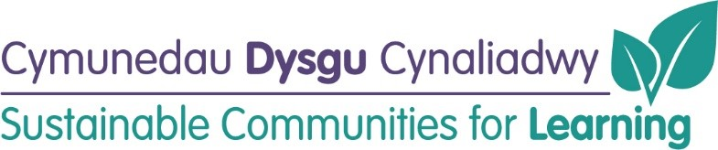

**New Build Glyncoed Primary School (Band B)**

**(updated June 2022)**

**Timeline for Delivery:**

|  |  |
| --- | --- |
| **Business Case:** | Submitted and Approved |
| **Project brief:** | Autumn-term 2020 **– Completed** |
| **Glyncoed Site investigations commencement:** | Spring 2020 **– Completed** |
| **Tender document preparation/ detailed design work:** | Summer 2021 **– Completed** |
| **Pre-planning consultation:** | April/May 2021 **– Completed** |
| **Planning submission:** | Autumn 2021 (potential timeframe - 6 months) **- Approved** |
| **Out to tender:** | Summer 2022 (6 - 8 weeks) **- Completed** |
| **Evaluation:** | Spring 2022 **- Completed** |
| **Contractor appointment:** | Summer 2022 **- Completed** |
| **Commencement:** | Summer 2022 (17-month construction period) |
| **Conclusion:** | Autumn 2023 |
| **Occupation:** | Autumn 2023/Spring 2024 |

**Old school Image**

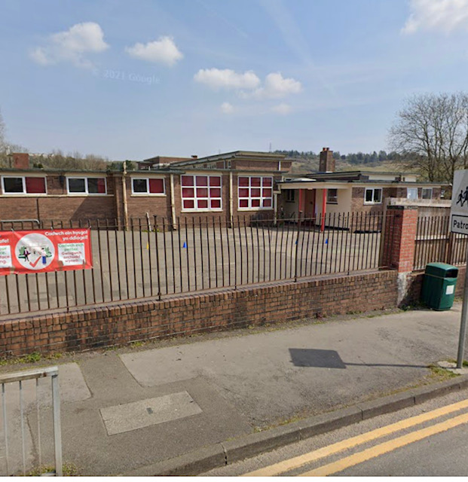

**Progress to Date:**

School Drawing



