Lighting the Way: Joe Nash, Our First Welsh Champion
27th June 2025

As we unveil our Welsh Champions Honours List—a tribute to individuals who celebrate, speak, and share the richness of the Welsh language—we are proud to present our very first honouree: the remarkable Joe Nash of Brynmawr.
At just 22, Joe embodies the passion, perseverance and purpose that define a true language champion. Born into a non-Welsh-speaking family, Joe's journey began at Ystruth Primary and Brynmawr Foundation School, where an inspiring French teacher, Joanne Morgan, first sparked his love for languages. That spark ignited a blazing path.
His academic journey took him from Blaenau Gwent Learning Zone, where he pursued A-levels in Biology, Spanish and Welsh Second Language, to Swansea University, where he deepened his fluency through a pioneering degree in foreign languages delivered through the medium of Welsh. He says, “Immersing myself in the language really helped me to achieve fluency—and I’ve met some truly amazing and inspirational people along the way.”
Joe’s thirst for culture and connection led him to Spain, where he not only mastered Spanish but also taught in local schools, sharing his love of language across borders. “I would be living a completely different life had I not learned to speak Welsh,” he reflects—testament to the transformative power of embracing a new tongue.
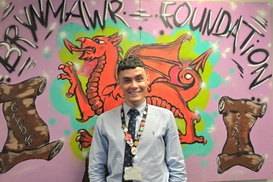
Now shaping young minds at Brynmawr Foundation School while completing his PGCE, Joe is not just teaching language—he is cultivating confidence, identity and cultural pride in his students.
With fire in his heart and vision in his stride, Joe Nash is more than our first honouree—he is the embodiment of what the Welsh language can achieve when it’s shared with courage, kindness, and commitment.
We congratulate Joe on becoming our first Welsh Champion. The future is brighter for every student who follows the trail he’s blazed.
To nominate your own Welsh champion just add your details and nomination on this link: Snapsurveys.com-welshchampion

