

**PROFORMA**

**GREEN INFRASTRUCTURE STATEMENTS &**

**BIODIVERSITY ENHANCEMENT SCHEMES**

***Householder applications and other small developments***

**Complete the boxes in this form and include with your planning application.**

**Refer to the accompanying guidance note for site-specific information.**

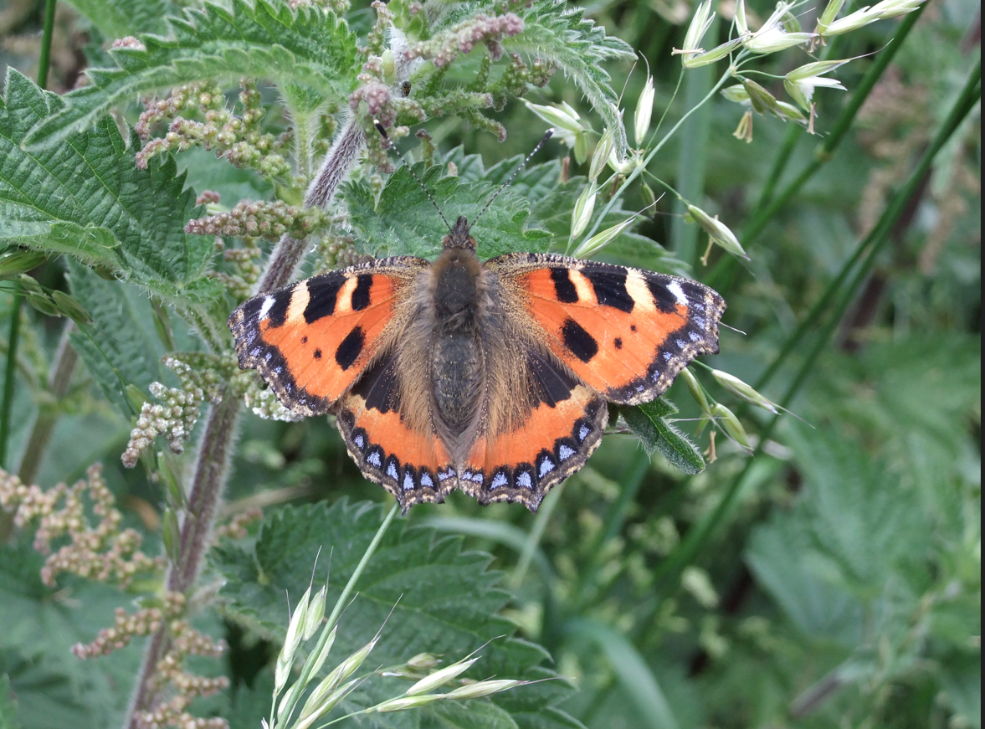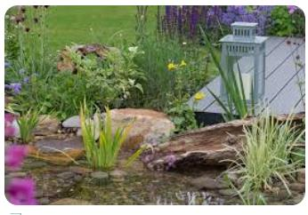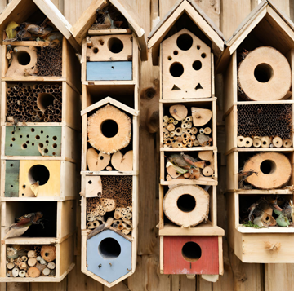

**Q. What is a Green Infrastructure (GI) Statement?**

A Green Infrastructure Statement describes how the natural value of a site (trees, hedges, and sustainable drainage (SuDs)) has been incorporated into the development proposal. A GI Statement should be proportionate to the scale and nature of the development.

**Q. Why do I need a Green Infrastructure Statement?**

A GI Statement is required on all developments following revisions to Planning Policy Wales (PPW)12, Chapter 6 published by Welsh Government and duties under the Environment (Wales) Act 2016. This requires new development to have a **net benefit** to biodiversity and green infrastructure. This information is **not** appropriate to seek ‘retrospectively’ by way of a condition and must be provided as part of the planning application process.

**Q. What is a Biodiversity Enhancement Scheme?**

To comply with the requirements, new developments must include details of biodiversity enhancement measures. These don’t always need to be costly or large in scale. It could, for example, include simple measures like bird boxes, insect boxes and the planting of native shrubs or flowers suitable for bees and other pollinators.

**Q. How do I provide the information?**

To assist in providing the information the Council requires, the associated form can be completed to provide the specific Green Infrastructure details that relate to each step of your proposed development.

**GREEN INFRASTRUCTURE STATEMENT**

|  |  |
| --- | --- |
| Form completed by: |  |
| Date: |  |
| Address of site: |  |
| Description of Proposal: |  |

1. **Details of all existing green infrastructure and biodiversity enhancements (e.g. trees, hedges, ponds, bird/bat boxes, insect houses etc) on site:**

|  |  |
| --- | --- |
| Boundary 1: |  |
| Boundary 2: |  |
| Boundary 3: |  |
| Boundary 4: |  |
| Front Garden: |  |
| Rear Garden: |  |
| Other: |  |

1. **What green infrastructure features have already been removed from site and/or require**

**removal to facilitate the development?**

|  |  |
| --- | --- |
| Boundary 1: |  |
| Boundary 2: |  |
| Boundary 3: |  |
| Boundary 4: |  |
| Front Garden: |  |
| Rear Garden: |  |
| Other: |  |

1. **How will the retained features be protected during development (i.e. BS5837:2012**

**Tree Protection Works)?**

|  |  |
| --- | --- |
| Boundary 1: |  |
| Boundary 2: |  |
| Boundary 3: |  |
| Boundary 4: |  |
| Front Garden: |  |
| Rear Garden: |  |
| Other: |  |

1. **What green infrastructure is being planted as mitigation for losses? Please show this on your block plan/landscaping plan in support of your application (see example in guidance note).**

|  |  |
| --- | --- |
| Boundary 1: |  |
| Boundary 2: |  |
| Boundary 3: |  |
| Boundary 4: |  |
| Front Garden: |  |
| Rear Garden: |  |
| Other: |  |

1. **What Landscaping is being planted to enhance Green Infrastructure? Please show this on your block plan/landscaping plan in support of your application (see example in guidance note).**

|  |  |
| --- | --- |
| Boundary 1: |  |
| Boundary 2: |  |
| Boundary 3: |  |
| Boundary 4: |  |
| Front Garden: |  |
| Rear Garden: |  |
| Other: |  |

1. **How will the new planting be managed and/or maintained?**

1. **Biodiversity enhancements**

The enhancements do not need to be directly attached to the proposed new construction; they can be attached to the existing house or placed within the garden, but they do need to be on land within the red or blue line that identifies the boundary of the planning application. The principle is that the enhancements will lead to a ‘net benefit’ for biodiversity. The following biodiversity enhancements have also been added:

The following biodiversity enhancements will be added:

|  |  |  |
| --- | --- | --- |
| **Type** | **Location** | **Info** |
|  |  |  |
|  |  |  |
|  |  |  |

1. **Declaration**

The information provided in this form has been given to the best of my knowledge.

**Site photos (optional)**

