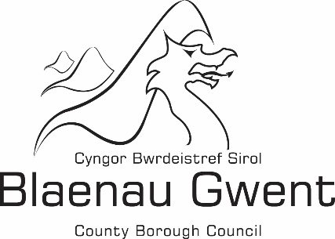

Statutory Notice:

Completion of the Audit of Accounts

Notice is given that pursuant to the Accounts and Audit (Wales) (Amendment) Regulations 2018, the audit of the Accounts for the financial year ended 31 March 2023 has been formally concluded and an unqualified audit opinion issued.

In accordance with Section 29 of the Public Audit (Wales) Act 2004, any local elector may inspect and make copies of these Accounts on application to the Authority at the following address:

Blaenau Gwent County Borough Council
The General Offices
Steelworks Road
Ebbw Vale
NP23 6DN

The approved Statement of Accounts can be found at the following location on the Council’s website:

https://www.blaenau-gwent.gov.uk/en/council/budgets-spending/statement-of-accounts/

Rhian Hayden

Director of Corporate Services

