Introducing another of our Welsh Champions for 2025: Amanda Smith
28th October 2025
You may know Amanda Smith as Amanda Masquerade – a talented face painter, balloon modeller, and magician. But she’s also a passionate Welsh learner who has been dedicated to mastering the language for several years.
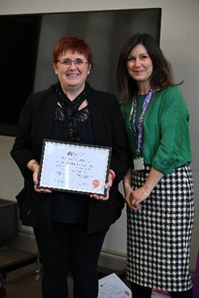
Amanda always wanted to learn Welsh but didn’t have the chance until her children were grown. What began as a casual interest eventually led to formal classes, and today she’s nearly fluent. Her journey has inspired those around her: although her children didn’t grow up speaking Welsh, they’ve started learning as adults, and her grandchildren now attend Ysgol Cymraeg Bro Helyg. Even friends and family who once thought she was “mad” for trying have joined in – and they’re loving it.
Her new language skills have opened countless doors. Amanda’s business has flourished, with bookings from Welsh organisations such as Menter Iaith, Mudiad Meithrin, local councils, Eisteddfods, the Urdd, and many more. She’s now in demand across Wales, and her social life has blossomed too. Amanda also works part-time at Ysgol Bro Helyg, helping children learn to read – just one of the many ways she shares her talents.
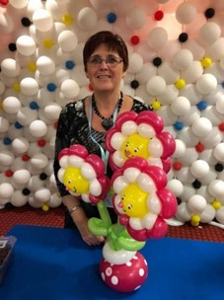
“There’s always time to use the language, no matter where I am,” she says.
When Amanda first began learning, there was only one class available. Now, there are countless opportunities – from online courses with Learn Welsh to mobile apps and community classes across Wales and beyond.
Her advice to new learners? “Just do it – and don’t give up. You might need to pause, but don’t quit.”
Amanda’s future is full of exciting plans. She recently completed a beautiful mural at Ysgol Bro Helyg showcasing highlights of the local borough. She hopes to continue supporting the school and also running bilingual knitting and crochet classes for the community. Her balloon modelling career is thriving, with regular bookings and an annual conference where she teaches artists from around the world. She’s also launching Saturday workshops at Coleg Gwent – perfect for anyone looking to try something new.
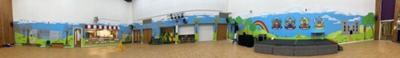
Whatever Amanda does next, we wish her all the best and thank her for everything she brings to our community. Her passion for Welsh language and culture makes her a truly deserving Welsh Champion.
To connect with Amanda, find her on Facebook: https://www.facebook.com/masquerade
Interested in learning Welsh or nominating your own Welsh Champion for our 2026 honours list? Get in touch via email: Cymraeg@blaenau-gwent.gov.uk

