Meet Our Final Welsh Language Champion for 2025: Steve Bard
13th November 2025
We’re thrilled to introduce Steve Bard, our final Welsh Language Champion for 2025, a true pillar of the Blaenau Gwent community and a passionate advocate for the Welsh language.
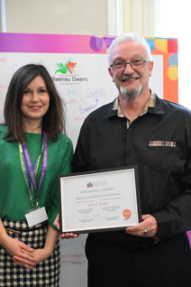
Born in Worcester and raised in Six Bells, Steve has been a familiar and beloved face in the area for decades. With over 49 years of dedication to the Abertillery Male Voice Choir, his musical journey has touched countless lives. As a committed Community Councillor, Steve has helped bring joy to the town through events like Party in the Park and Wales in Bloom, where the community proudly earned a silver award.
Steve’s love for Welsh began in 2010 when the Eisteddfod came to Ebbw Vale. After performing with his choir, he stumbled into Maes D, the Welsh learners’ tent, and it was love at first sound. He immediately enrolled in a Mynediad course with Dysgu Cymraeg and progressed to Canolradd level, becoming a confident Welsh speaker. Though life made it difficult to continue formal classes, Steve remains deeply committed, weaving Welsh songs into the choirs he conducts and performs with.
Inspiring the Next Generation as a supply teacher at Monmouth High School, Steve often steps in to teach Welsh lessons. His enthusiasm is infectious; he encourages students to embrace the language and culture with pride and curiosity.
Building Community Through Language Steve found a vibrant community of learners through a Facebook group, connecting with others across the UK for Welsh-only weekends away. “We just book an Airbnb and meet up; we try our best to only speak Welsh. I’ve made some lovely friends through this group, and we’re planning another trip soon. It’s the best way to learn!”
A Champion in Every Sense from running Tyleri Travel in Abertillery to conducting and singing in multiple choirs, Steve brings his love for Welsh and his community into everything he does. His energy, warmth, and dedication make him a truly deserving member of this year’s Welsh Champion honours list.
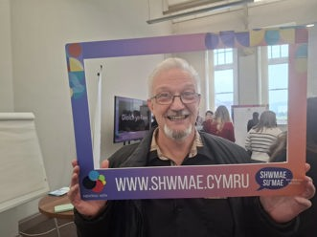
Know someone who champions the Welsh language and culture?
Nominate them today and help us celebrate those who go above and beyond to keep our heritage alive! Send you r nominations to: Cymraeg@blaenau-gwent.go.uk
Want to start your Welsh journey: https://learnwelsh.cymru/

