**Community Meals**

**Service**

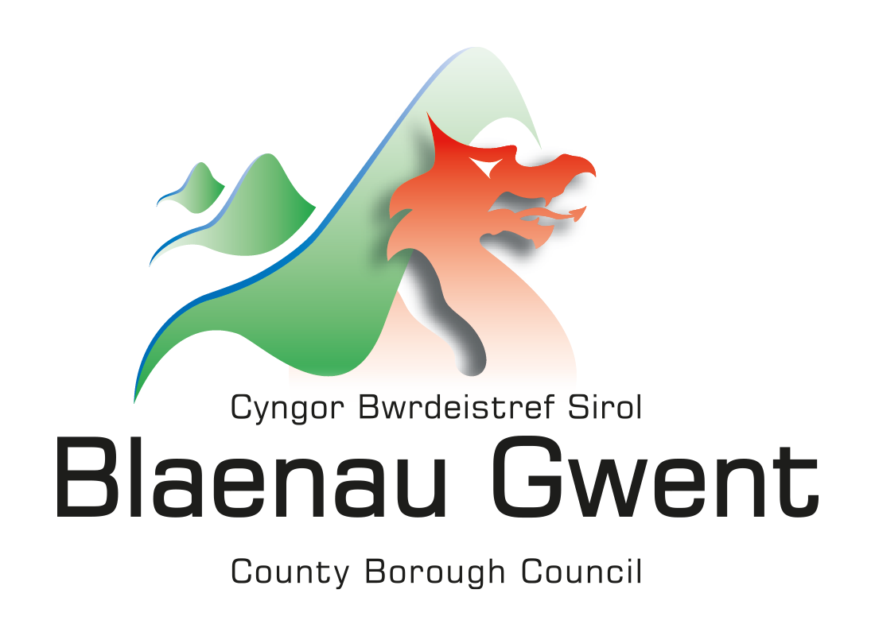

**New Customers 01495 315700**

**Existing customers 01495 369638**

About the service

We deliver hot, tasty and nutritious meals and most recently **Afternoon Tea** to anyone who lives in the Blaenau Gwent area. Our caring, friendly team also carry out vital welfare checks while they are delivering your meal. Anyone of all ages can apply for our delivery service. You do not need a referral from social services or your GP.

**Details of the service**

* We deliver hot meals between 11.00am and 1.30pm, 5 days a week Monday to Friday, the meal is ready to eat straight away. In addition to this, we also deliver frozen meals which will need to be heated in a traditional oven.
* You can choose from a wide-ranging menu offering a number of choices.
* Afternoon Tea, freshly baked/prepared;

|  |  |
| --- | --- |
| **Example 1** | **Sandwiches** (variety of fillings) inclusive of a salad garnish, crisp and a desert of your choice i.e. Cake- Trifle - Scone with fresh clotted cream/jam |
| **Example 2** | **Savoury only:** Scotch egg – Pork Pie - Sausage roll – Pasty – Cheese & Crackers etc…. **with no desert** |
| **Example 3** | **Ham Salad,** a boiled egg andcrisp. |

**Please are see our enclosed Afternoon Tea menu. Most specific dietary requirements can be accommodated, inclusive of; diabetic – vegetarian - low fat and gluten free. We also provide a full Allergen list of all ingredients.**

The person delivering your meal will support you in;

How can we help you?

* Encourage you to eat your meal.
* Support you with small tasks such as; preparing cutlery - removing packaging – plating up/ cutting up your meal if you are unable to.
* We will also check that you are comfortable and secure, we will do this each time we visit you and, if there is a problem we can contact your family- friend or Doctor if you need them.

**How much does the service cost?**

* One hot meal including one dessert = £5.66
* One Frozen meal including one frozen dessert = £5.66.
* Afternoon Tea = £3.67
* Cakes/Deserts sold separately = 70p

**If you’re not going to be in!!**

* If you’re going out and won’t be home to take delivery of your meal, please let us know by calling **01495 369638.**
* If you wish to cancel your meal on the same day it is due to be delivered, please ensure you call us before 9.00am to avoid being charged.

**Please note: our Driver will not leave your hot meal on the doorstep for you to reheat later – if you allow it to cool and then reheat, you are at risk of food poisoning.**

If you have any queries, or need advice please contact call; 01495 369638

Yours Sincerely

Claire Davies – Community Options Manager

Social Services – Adult services Provider Services

**Community**

**Meals**

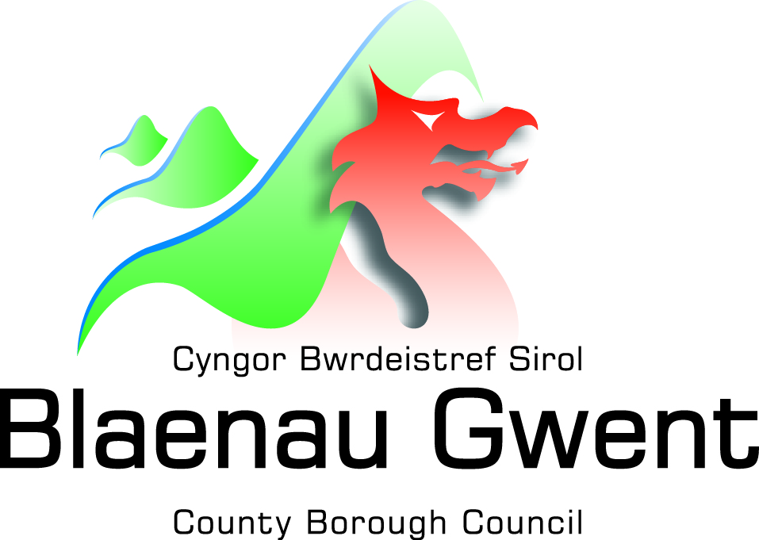

**Telephone 01495 355949**

***Afternoon Tea Box***

***Menu***

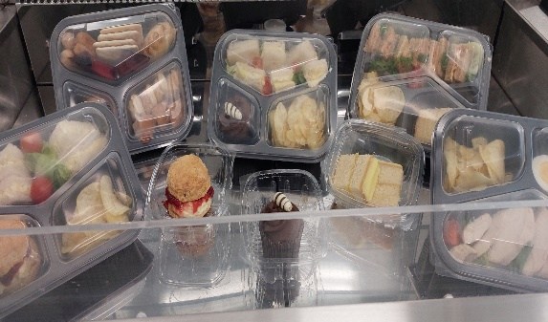We are pleased to introduce our Tea time boxes which consists of a variety of options for you to choose from. Order from the comfort of your home and we will deliver to your door!!!

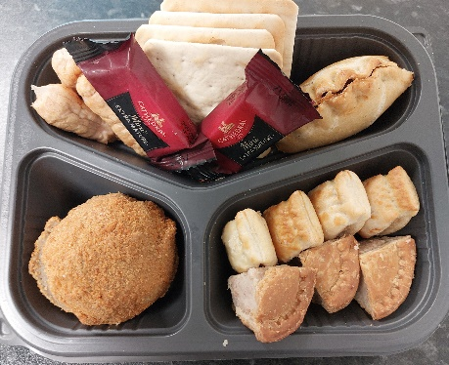

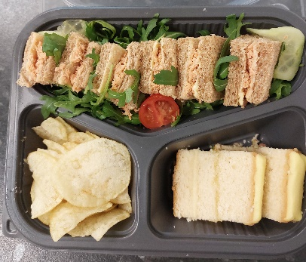 ***We have 3 options for you to choose from: (Sandwiches are prepared with White or Brown bread, please specify when ordering…***

***Menu Choices***

**Telephone 01495 369638**

|  |
| --- |
| **Option 1**  1 x Sandwich with one filling inclusive of a Salad garnish and crisps, plus one cake or desert of your choice (***Choose from menu below***) £3.67p |
| **Option 2**  Sliced Chicken breast on a bed of crispy salad along with a boiled egg and Crisps  £3.67p |
| **Option 3**  4 x Savoury portions of your choice with salad garnish with no Desert (***Choose from menu below***) £3.67 |
| **Cakes 70p**  **All Deserts 70p** |

**If you have a favourite Sandwich filling or Tea Time foods which we have not included, please let us know as we value your comments**

|  |  |
| --- | --- |
| ***Sandwiches fillings*** | ***Cakes*** |
|  | Scone – freshly baked with Jam and Clotted Cream |
| Sliced Ham - with or without mustard | Lemon Drizzle cake |
| Cheese & Onion | Cupcake - Coffee /Lemon/ Chocolate |
| Tuna Mayo | Victoria sponge |
| Cornbeef & Pickle | Black Forest Gateaux |
| Egg Mayo | ***Deserts*** |
| ***Savoury*** | Trifle – Strawberry / mixed fruit |
| Quiche Lorraine | Ice Cream |
| Sausage Rolls | Mousse – Strawberry /raspberry /Lemon/Chocolate |
| Small Pasty  Cheese & Crackers | Yoghurt |
| 4 Mini savoury eggs |
| Cheese Scone |
| Mini Sausages |
| Pork pie/ egg sliced |



We thought you would like to see what you’re your chosen Tea Time Box will look like

Egg Mayo Sandwich with Salad garnish, Crisps and Chocolate Cup Cake £3.67

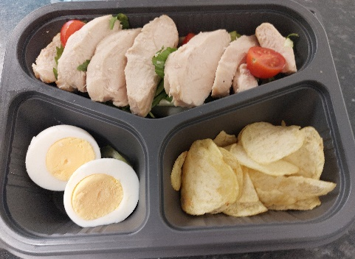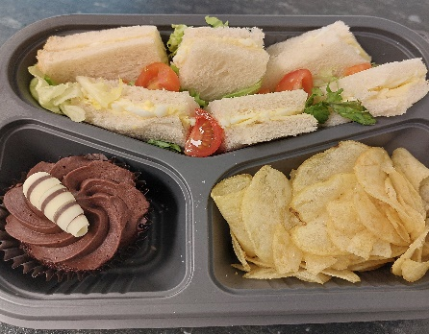

Sliced Chicken breast on a bed of Salad – Boiled Egg and Crisps £3.67

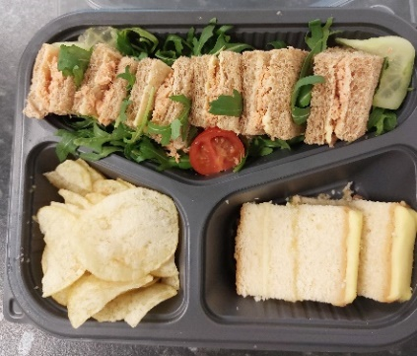

Red Salmon Sandwich with Salad garnish, Crisps and Lemon Drizzle Cake £3.67

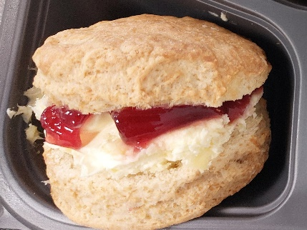

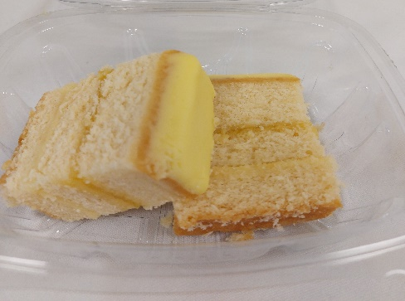

Lemon Drizzle Cake £0.70p

**“Ewch i food.gov.uk/ratings i ganfod sgôr hylendid bwyd ein busnes neu gofynnwch inni beth yw ein sgôr hylendid bwyd wrth archebu./ Go to food.gov.uk/ratings to find out the food hygiene rating of our business or ask us for our food hygiene rating when you order.”**

**‘Before ordering, please speak to a member of staff if you have any food allergies or intolerances.’**

Freshly baked Scone with Clotted cream and Strawberry Jam £0.70