
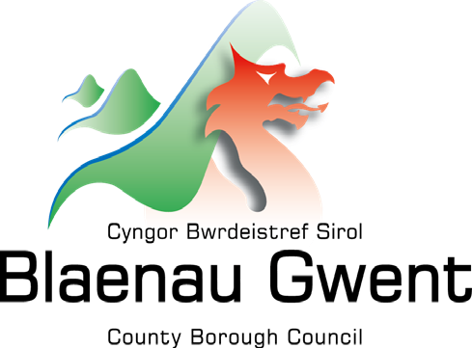
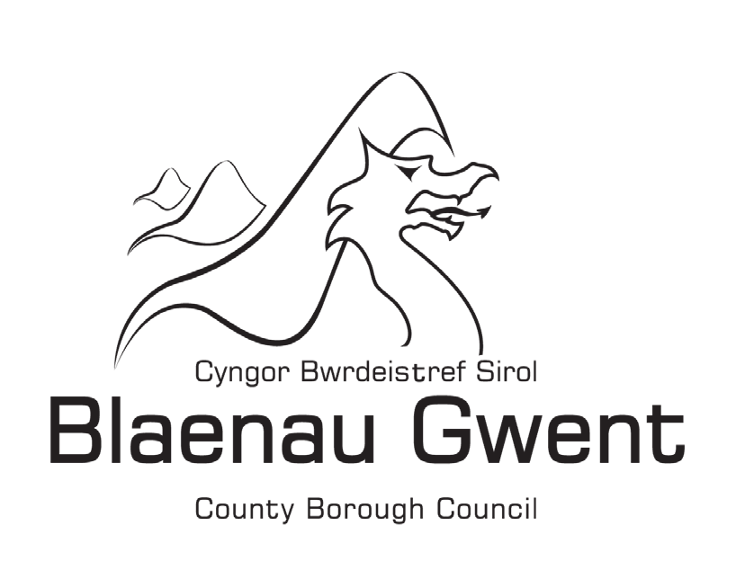

Catchment Area
Review Consultation

Start Date: Noon on 12th December 2025
Consultation Overview
annual
End Date: 5th January 2026 at 5p.m.
This consultation aims to:

- To establish a defined catchment area for Brynmawr Foundation School, which is currently the only secondary school in Blaenau Gwent without one, and

- To establish a designated catchment area for Ysgol Gymraeg Bro Helyg and Ysgol Gymraeg Tredegar.

The primary goal of these proposed changes is to enhance clarity for families regarding school admissions, achieve a better balance in pupil numbers across schools, and support robust planning for future school places.

The proposed changes are intended to be incorporated into the School Admission arrangements for the 2027/2028 academic year.

For reference, the School Admission Policy for 2026/27 can be accessed through the following link: School admissions | Blaenau Gwent CBC

How to participate in the Consultation
anual

We encourage everyone to review the information provided and share their views, questions, or comments.
emailing: schooladmissions@blaenau-gwent.gov.uk with the subject heading "Catchment Area Review." Please indicate your preferred option for each of the proposals.

Alternatively, you can participate by completing a snap survey: https://online1.snapsurveys.com/410wpu

Additionally, a drop-in consultation session has been organized for further engagement.

Please note that all feedback must be submitted by 5:00 PM on 5th January 2026. Comments received after this deadline will not be considered.

A drop-in session will be held at Goldworks, Mill Lane, Ebbw Vale, Blaenau Gwent. NP23 6GR on Wednesday 17th December 2025. Staff will be available between 4p.m and 6p.m and will be able to answer any questions you may have.

Consultation Requirements
anual

The Admissions Code 2013 requires all admission authorities to consult annually on their admission arrangements. Where proposals to existing arrangements are made i.e. If there are changes to catchment areas, a consultation must be held with all potentially affected parties.

Issues Identified
anual

There are a number of primary school catchment areas in Blaenau Gwent that do not align with their nearest secondary school. These catchments require review to determine if changes are feasible. Additionally, there are imbalances within current primary and secondary school catchments, with some areas experiencing regular oversubscription.

Brynmawr Foundation School is the only secondary school within Wales that hasn’t for a designated catchment area.

There is currently one catchment area for the whole of Blaenau Gwent in relation to welsh medium primary education. During the 25/26 academic session a new welsh medium primary school has opened in Tredegar, there is a need to establish a catchment area for both school sites.

While the proposals in this stage are not financially motivated, a comprehensive cost analysis will be conducted to evaluate the financial impacts of each proposal.

Consultation Proposals
anual

The Council is consulting on the following options in relation to establishing a catchment area for Brynmawr Foundation School and Ysgol Gymraeg Tredegar. Please read each option carefully and consider the advantages and disadvantages before submitting your preferred choice:

Proposal 1: Establishing a catchment area for Brynmawr Foundation School

Option 1

- To introduce a catchment area for Brynmawr Foundation School to include the catchment areas for Beaufort Hill, Blaen y Cwm, Coed y Garn and Ystruth Primary Schools and amend the catchment areas for Ebbw Fawr Learning Community and Abertillery Learning Community.

Option 2

- To introduce a catchment area for Brynmawr Foundation School to include the catchment areas for Blaen y Cwm, Coed y Garn and Ystruth Primary Schools and amend the catchment area for Abertillery Learning Community.

Proposal 2: Establishing a catchment area for Ysgol Gymraeg Tredegar

Option 1

- To establish a catchment area for Ysgol Gymraeg Tredegar to include Tredegar and Ebbw Vale and amend the current catchment area for Ysgol Gymraeg Bro Helyg.

Aims of the Proposals
anual

- Establish a new catchment area for Brynmawr Foundation School to promote a more balanced distribution of pupils and school places across secondary schools in the Borough.
- Achieve a balance in pupil numbers and available places in both Ebbw Fawr Learning Community Secondary Phase and Abertillery Learning Community Secondary Phase catchment areas.
- Balance the number of pupils seeking Welsh-medium education across the Borough.
- Realign catchment areas for Abertillery Learning Community and Ebbw Fawr Learning Community.
- Where possible, address situations where the catchment school is not the nearest school for some pupils.
- Resolve imbalances within current catchment areas to ensure robust planning for school places.

Any proposed changes to catchment areas are subject to statutory consultation which requires a Local Authority/Foundation School to consult if it wishes to vary the catchment areas for schools.
It is important to note that these proposals only relate to admission intake for September 2027 onwards.

Proposal 1: To establish a catchment area for Brynmawr Foundation School

anual

Rationale for the proposal

All secondary schools in Blaenau Gwent, except Brynmawr Foundation School, currently have defined catchment areas comprising of associated primary school catchments. The proposal seeks to address this gap.
The catchment areas of Beaufort Hill, Blaen y Cwm, Ystruth and Coed y Garn primary schools have been chosen for Brynmawr Foundation School as they are the closest to the school.

Under Option 1, the catchment areas for Coed y Garn, Ystruth, Blaen y Cwm, and Beaufort Hill Primary Schools would transfer from their current secondary school catchment areas to form the new catchment area for Brynmawr Foundation School.

Under Option 2, the catchment areas for Coed y Garn, Ystruth, and Blaen y Cwm Primary Schools would transfer from their current secondary school catchment areas to form the new catchment area for Brynmawr Foundation School.

The proposal will also help to manage the situation of pupil places due to the continued increase of inward migration into the Borough which in turn will impact on school pupil capacity.

Allocation of pupil places

Applications are considered after the closing date. All applications received by the closing date are considered and places allocated.
If more applications are received for a school than places available the over subscription criteria is applied:

Applications are considered in the following priority order:
- Children Looked After (children under the care of the Local Authority)
- Catchment (pupils residing within the school's catchment area)
- Social/Medical grounds (exceptional needs)
- Sibling (applicants with an older sibling attending the same school)
- Distance (proximity to the school, measured digitally)

Admissions are based on the pupil's home address and not the primary school the pupil attended. For more details, refer to the School Admissions Policy.

Proposed Catchment Maps

Maps illustrating current and proposed catchment areas for Brynmawr Foundation School and associated primary schools are provided to assist to visualise the changes under each option.

Figure 1: Map showing the current 3 catchment areas (Tredegar Comprehensive; Ebbw Fawr Learning Community and Abertillery Learning Community)

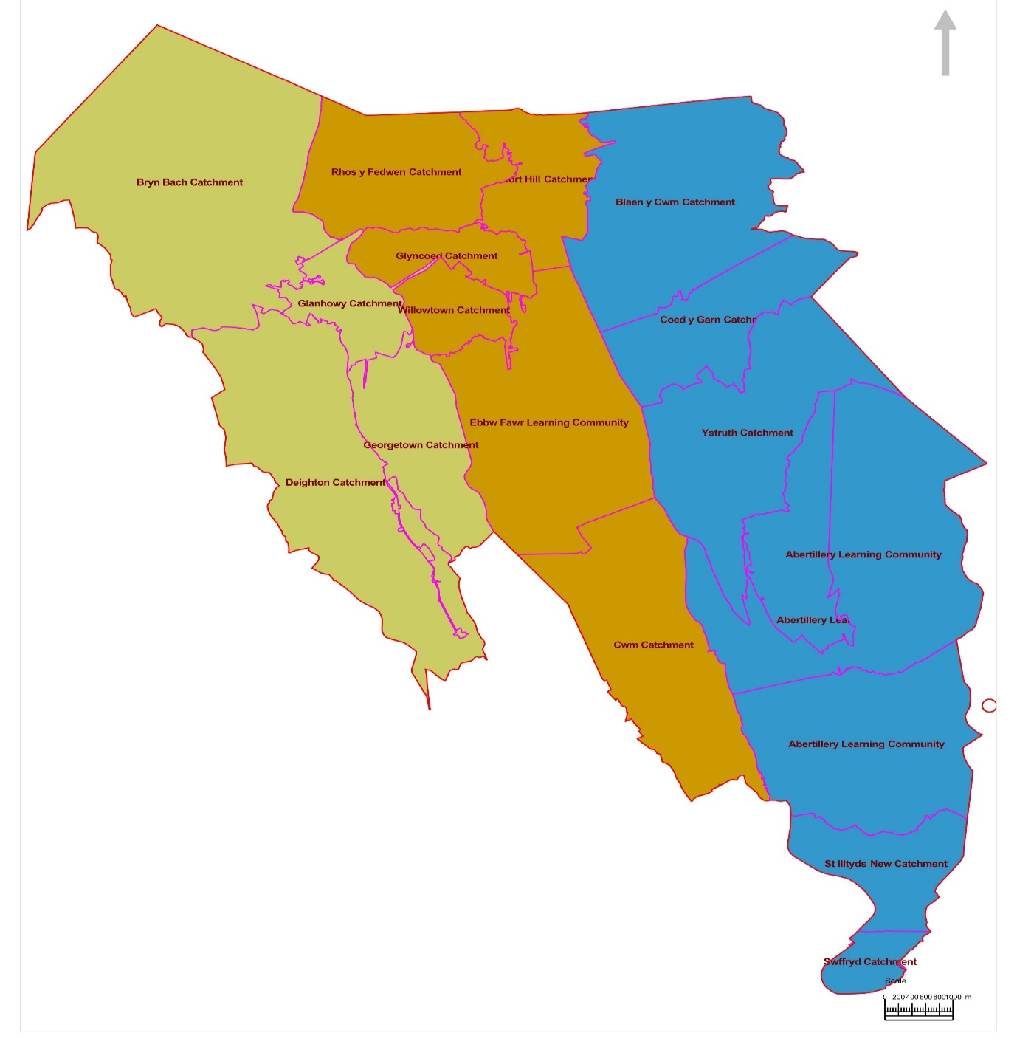

Figure 2: Map showing the catchments areas for Proposal 1 Option 1 with the catchment area for Brynmawr Foundation School including the catchment areas for Beaufort Hill, Blaen y Cwm, Ystruth and Coed y Garn primary schools
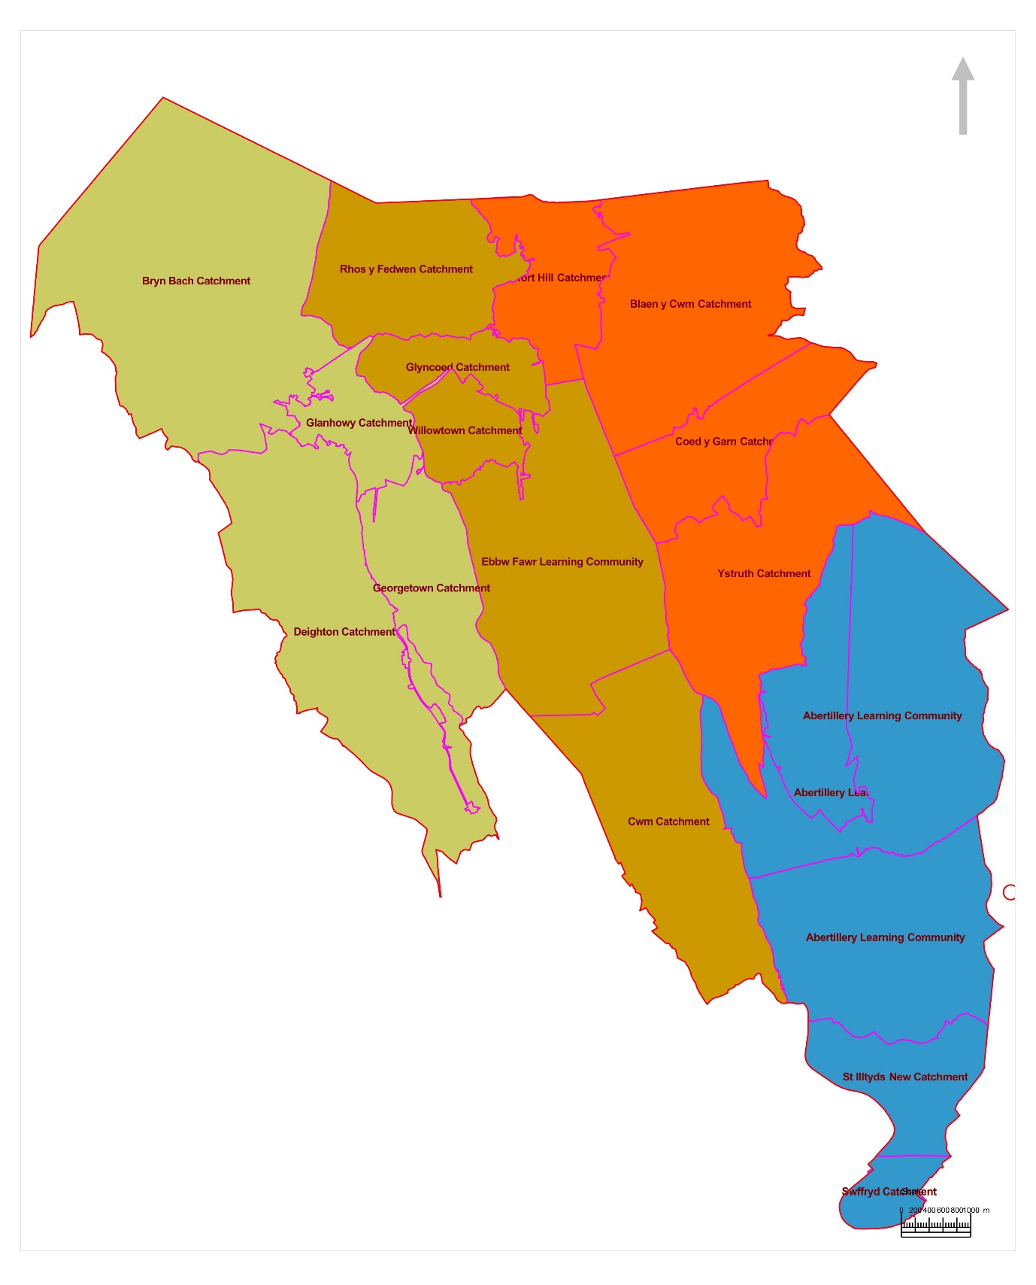

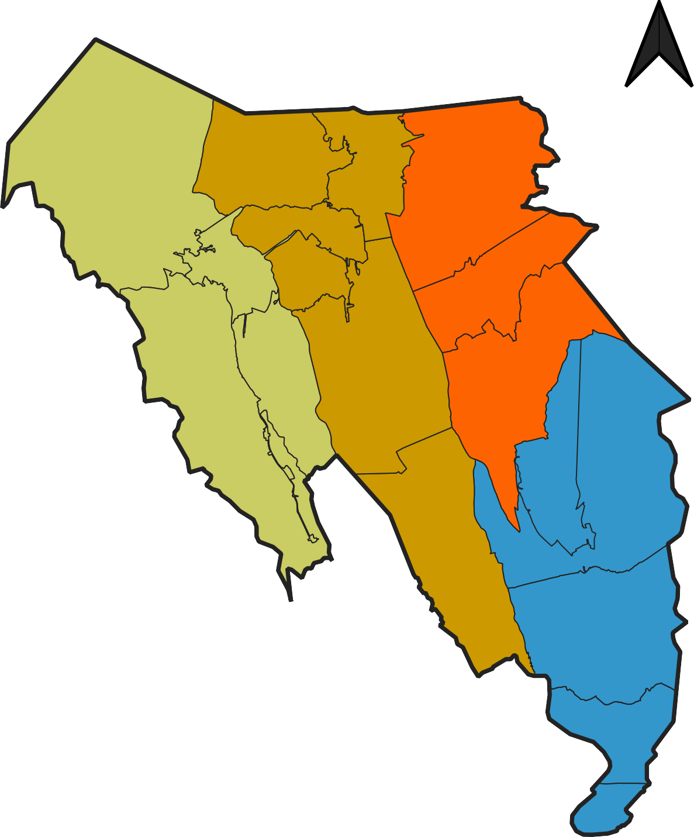
Figure 3: Map showing the catchments areas for Proposal 1 Option 2 with the catchment areas for Brynmawr Foundation School including the catchment area for Blaen y Cwm, Ystruth and Coed y Garn primary schools
Key
D

Benefits and Disadvantages of the proposal
Benefits of both options

- All four secondary schools will have their own designated catchment areas.
- All four secondary schools will have an equitable catchment area with a comparable number of feeder primary schools.
- Catchment areas will contribute to oversubscription criteria, giving priority to pupils residing within the area.
- The proposal supports current transition links between Blaen y Cwm, Coed y Garn, and Ystruth Primary Schools.
- Some pupils will have reduced travel distances to school, particularly those living closer to Brynmawr Foundation School than their current designated secondary school.
- Pupils in certain areas would qualify for free home-to-school transport to Brynmawr Foundation School.
- Balances pupil numbers more effectively across all four secondary schools in Blaenau Gwent.
- Provides greater choice for families in the northern part of Blaenau Gwent.

Disadvantages of both options

- Pupils from areas impacted by the proposal can continue to apply to their existing catchment secondary school; however, they will be given lower priority if the school is oversubscribed

Proposal 2: To establish a catchment area for Ysgol Gymraeg Tredegar

anual

Rationale for the Proposal
The Council proposes to create a designated catchment area for Ysgol Gymraeg Tredegar, along with adjustments to the catchment area for Ysgol Gymraeg Bro Helyg. This change will provide families with greater clarity about school options and improve access to local Welsh-medium education. A more balanced distribution of pupils between the Welsh primary schools across the Borough is also anticipated.

The following maps are provided to illustrate both current and proposed catchment areas under this proposal.

Figure 4: Map showing the current catchment area for Ysgol Gymraeg Bro Helyg
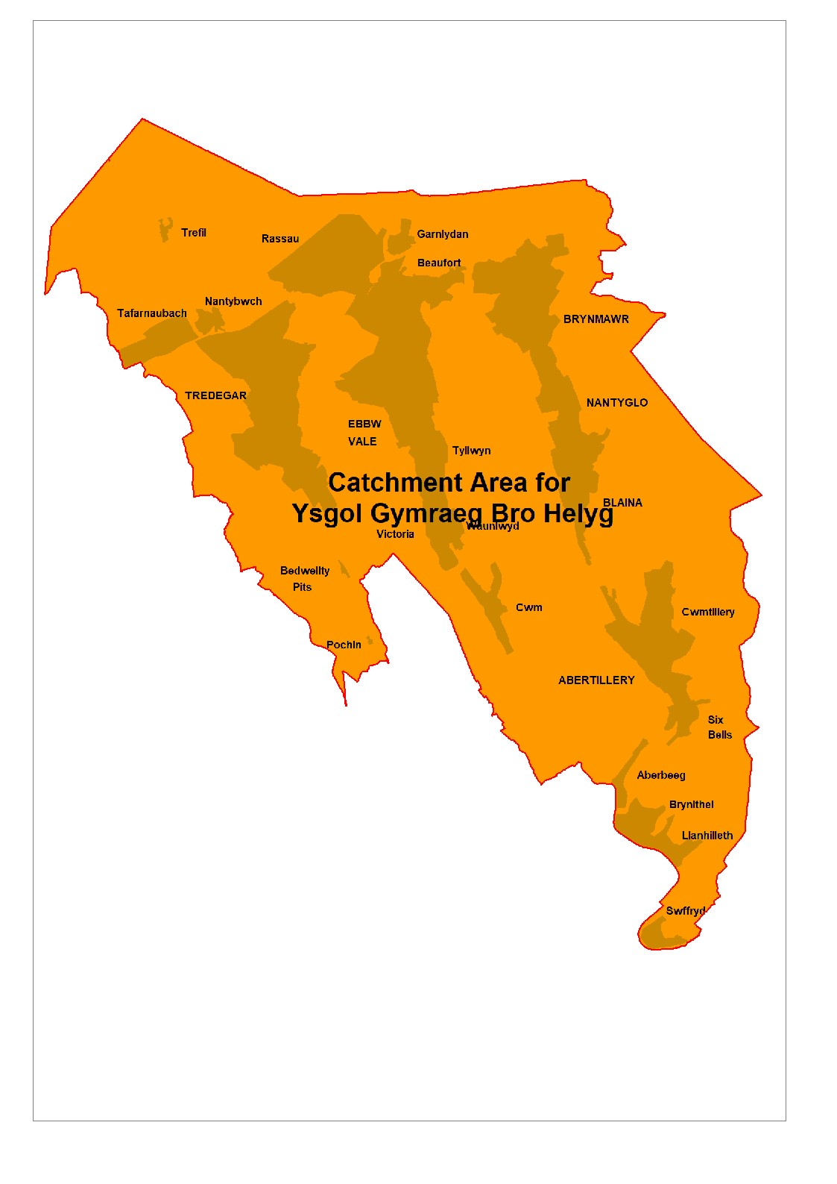

Figure 5: Map showing the catchments areas with Option 1 for Proposal 2
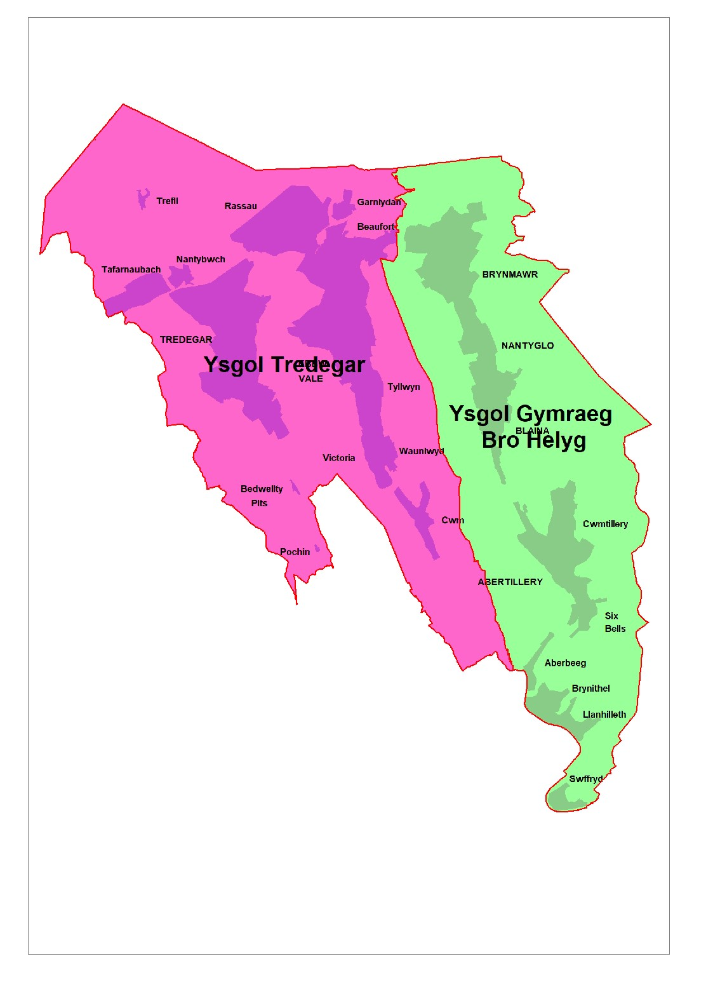

Benefits

- Both Welsh primary school sites will have their own designated catchment areas.
- Catchment areas will play a role in oversubscription criteria, giving priority to pupils within the area.
- Pupils seeking Welsh-medium education may have shorter travel distances to school.
- Balances the number of pupils receiving Welsh-medium education across the Borough.

Disadvantages

- Pupils living in Tredegar and Ebbw Vale may still apply to Ysgol Gymraeg Bro Helyg but will receive lower priority in the event of oversubscription.

Financial Implications

While the implementation of the proposals may increase Home to School Transport costs in the short term, this is however expected to be cost neutral in the long term. Any additional costs will be managed within the existing Home to School Transport budget with no cost pressure to the Council.

Travel Arrangements

All pupils affected by either of the proposals will receive the same home-to-school transport support as currently provided throughout the Borough. The Council’s policy is as follows:
- Free transport is provided to the nearest suitable school if the distance from home to school exceeds 1.5 miles for children under 8 years old at the start of the academic year. This transport remains in place for the entire school year.
- Free transport is provided for children aged 8 years and over if the distance from home to school exceeds 2 miles at the start of the academic year.

Welsh Language Impact

The proposals are not expected to negatively affect the provision or promotion of the Welsh language.

Equalities Impact

An Equality Impact Assessment (EIA) has been conducted, and the proposed changes to catchment areas are not anticipated to have a negative impact on any protected characteristic. The proposals are inclusive, with appropriate mitigation in place for potential risks. Ongoing monitoring and transparent communication are recommended to ensure equality is maintained throughout implementation.

Next Steps

The consultation closes at 5:00 PM on 5th January, 2026.

Once closed, the Council will gather, review, and summarise all feedback received. A report will be presented to the Cabinet in April 2026, at which time a decision will be made in relation to each proposal.
The report will be made available for all consultees to view.

Admission arrangements for the 2027/28 academic year, which these proposals will form part of, must be finalized by April 16, 2026.

How to Submit Your Views

You may submit your views by:
emailing: schooladmissions@blaenau-gwent.gov.uk and indicate for Proposal 1 which option you prefer and if you agree to the option for Proposal 2.

Alternatively, you can complete a snap survey: https://online1.snapsurveys.com/410wpu

If you have any questions, please contact the School Operations team using the details above.

The deadline for responses is 5:00 p.m. on January 5th 2026.

For additional queries, please contact the Admissions Team at: schooladmissions@blaenau-gwent.gov.uk .

