****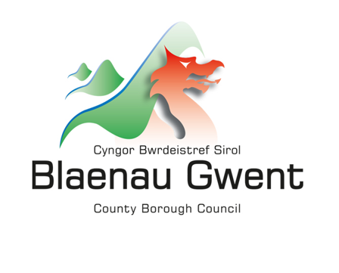

**Multiply Grant Application Guidance**

**Target audience**

Target learners are **adults 19+** who have not previously attained a Level 2/ SCQF Level 5 or higher maths qualification. They can either be working towards a maths Level 2/ SCQF Level 5 or Functional Skills Qualification, need specific numeracy skills for their work or progression, or just want to brush up on the skills to help them get on in life and work.

A level 2 qualification is defined on the [Credit and Qualifications Framework Wales](https://www.gov.wales/credit-and-qualifications-framework-cqfw) in line with the qualification specification and guidelines by the relevant awarding organisation. It must be the full qualification.

When referring to learning it means a single episode of substantive guided learning which lasts over two hours.

When referring to programme/courses it means a coherent package of learning which may include a regulated qualification, units of a regulated qualification or non-regulated learning with clearly stated aims supporting agreed outcomes.

When delivering non-regulated learning you must ensure you have appropriate and robust quality assurance in place.

You must not fund a learner who is unable to complete a learning aim, programme or course in the time they have available.

You must not fund a learner to repeat the same regulated maths or numeracy qualification where they have previously achieved a GCSE grade 4/C

You must not fund a learner to sit or resit a learning aim assessment or examination where no extra learning takes place.

**Existing arrangements**

Interventions should not displace, replace and / or duplicate any existing adult numeracy provision. Multiply boosts funding for adult numeracy, enabling local areas to deliver more innovative approaches and reach more people. We expect organisations to demonstrate how this is complementary and different to existing interventions in their project proposal.

The application form:

**Applicant information:** This is the name of the person completing the application on behalf of the organisation. Address and contact details should be for the organisation, not personal data.

**Value Being Requested:** Total amount that the applicant is requesting from the Shared Prosperity Fund Multiply grant scheme. The Multiply Grant is open to bids between £50,000 - £250,000 over a 2 year period (April 2023 – April 2025) with the possibility of the second year being withdrawn if the project does not meet its targets in the first year.

Projects of smaller values can be supported by umbrella organisations who wish to apply to fund multiple smaller initiatives. The umbrella organisation will have full responsibility for the administration, payment and monitoring of smaller projects. Umbrella organisations will be held to the same scrutiny as single project holders.

**What intervention does your proposal correspond to:** Blaenau Gwent CBC are committed to addressing all interventions. Where your project aligns with more than one intervention please indicate with a percentage measure e.g.

*W34: Employment support for economically inactive people 75%*

*W43: Funding to support engagement and softer skills development for young people, with regard to the work of Careers Wales/Working Wales 25%*

**Applications demonstrating the ability to address the following interventions will be scored higher as these have been identified as areas requiring external support:**

W46: Courses aimed at prisoners, those recently released from prison or on temporary licence.

W47: Courses aimed at people who can’t apply for certain jobs because of lack of numeracy skills and/or to encourage people to upskill in order to access a certain job/career.

W48: Additional relevant maths modules embedded into other vocational courses.

W49: Innovative programmes delivered together with employers – including courses designed to cover specific numeracy skills required in the workplace.

W50: New intensive and flexible courses targeted at people without Level 2 maths in Wales, leading to an equivalent qualification (for more information on equivalent qualifications, please see [Qualifications can cross boundaries](https://www.sqa.org.uk/sqa/files_ccc/QualificationsCanCrossBoundaries.pdf) (PDF, 974KB)).

W51: Courses designed to help people use numeracy to manage their money.

W52: Courses aimed at over 19s that are leaving, or have just left, the care system

W53: Activities, courses or provision developed in partnership with community organisations and other partners aimed at engaging the hardest to reach learners – for example, those not in the labour market or other groups identified locally as in need.

**Project Summary:**

Provide describe the project as simply as possible. Do not use technical terms, explain any acronyms. If an assessor cannot understand the project it cannot be assessed against the selection criteria and the bid will be rejected.

**Project Name**: The name of project being proposed not the organisation name.

**Project Proposal:** Please give an overview of what the project intends to do.

**Who will deliver the activities?** **How will the activities be delivered?**

**Who will be the beneficiaries of the project? Where will the activities take place?**

Clearly explain what the project intends to do and how it will be done. Be as straightforward as possible. If it helps to use diagrams these can be inserted into the application. When reviewing your bid consider the following questions from the point of view of someone who knows nothing about the organisation or the project:

* is it clear what the project would do?

* is it clear who will deliver the activities, who is involved and their roles?

* is it clear how, when and where the project will be delivered (ie. will the project deliver one to one support, one to many events/activities, will it be delivered in a specific location, on business or personal premises)?

* is it clear which individuals and businesses will benefit from the project, is there a focus on certain groups of people or types of businesses?

* is it clear how the project activities reflect the investment priorities?

If the project will work with people or businesses, you can summarise the customer journey using a flow chart showing specific project activities. A logic model or theory of change may also help explain your proposal.

**Project dates:** Please enter the project timeframe.

**What are the key milestones for the implementation and delivery of the project?**

These key milestones must link to the proposed activities and demonstrate that the project is deliverable within the project dates. Do not include milestones relating to the approval of the bid. Consider:

* securing internal approvals for the project or any other funding

* establishing the project team

* procurement for external services/suppliers

* project launch and recruiting beneficiaries

* key points on the beneficiary journey

Projects will be monitored against these milestones.

**What experience does the organisation have of delivering this type of activity?**

It is essential that organisations can draw on relevant experience and are able to demonstrate they have access to the resources and expertise they need to deliver the project. Projects that can demonstrate a partnership approach will be scored more highly.

**What outcomes and outputs do you anticipate the project to achieve (please give numbers) and how will you evidence these?**

Provide information on project outcomes and outputs and explain how the figures have been estimated. For example, explain the relationships between the number of intended final beneficiaries and the outcomes you intend to achieve?

Projects will be required to report on the number and type of beneficiaries supported and the outcomes and outputs achieved and will be monitored against these targets.

Project Outputs:

*Number of adult numeracy courses run in a local area through Multiply (numerical value)*

*Number of people participating in Multiply funded courses (numerical value)*

*Number of people achieving a qualification (numerical value)*

*Number of courses developed in collaboration with employers (numerical value)*

*Number of people referred from partners onto upskill courses (numerical value)*

*Number of different cohorts participating in numeracy courses (e.g. learners in prison, parents etc) (numerical value)*

Project Outcomes:

*Number of adults achieving maths qualifications up to, and including, Level 2 (numerical value) –* **Applications demonstrating the ability to address this outcome will be scored higher as it has been identified as areas requiring external support.**

*Number of adults participating in maths qualifications and courses up to, and including, Level 2 (numerical value)*

**How much Multiply investment is sought (Please give a breakdown of funding request)?**

Summarise the amount that will be spent under main areas of expenditure. The breakdown must be detailed enough to demonstrate that the funding package and budget is appropriate to the proposed activities and sufficient to deliver the project. The project will be monitored against expenditure.

**Does the funding package include any match funding? If so, how much?**

Match funding is any funding other than funding from the Shared Prosperity Fund that will be used to meet project costs. This includes from the project applicant or other organisations including income from beneficiaries. Please set out who match funding will come from, where relevant.

**When will any funding that is not in place be secured?**

If the project relies on match funding and it is not secured, explain when it is expected to be secured and what the impact would be if it is not secured.

**How has the overall budget been estimated, what has been done to test that it is accurate, how would any unexpected costs be managed?**

Describe how the figures provided were estimated. For example

* staff costs of X posts at salaries of £Y pro-rata for Z months of activity

* grants of between £X and £Y at an average of £Z per grant multiplied by the number of expected beneficiaries

* materials at a cost of £X per beneficiary multiplied by the number of expected beneficiaries

Explain what has been done to test the budget is accurate and how any unexpected costs or cost increases would be managed.

**Subsidy Control**

If the project will provide support to businesses or public / voluntary sector organisations that are operating in a commercial way there is potential for this support to represent a subsidy.

If the project would involve the award of subsidies explain how this will be managed in line with the UK’s obligations. For example, small scale awards can be managed under the threshold for Special Drawing Rights (or De Minimis where State Aid applies).

If the project provides support to businesses but you feel this does not constitute a subsidy explain why.

**Branding and Publicity**

As per UK government guidelines: The following logos must also be used when communicating in English and Welsh respectively:

 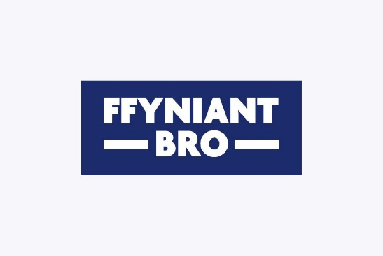

Alongside use of the appropriate UK government logos, lead local authorities and project deliverers must also ensure that websites and printed materials include a clear and prominent reference to the funding from the UKSPF. This includes any preparatory activity linked to the Fund.

We will require project deliverers to install a plaque of significant size at a location readily visible to the public, bearing the appropriate UK government logos, project name and standardised text. Plaques should be bilingual in English and Welsh in Wales.

Co-branding is only permitted with lead local authorities (or any strategic geography branding) or funders.

**Project Applicant Statement**

This section requires the acknowledgement and signature of the applicant and one other senior person within the organisation, be it the Chairperson, Vice Chair or Treasurer or Trustee.