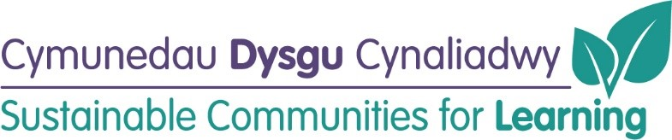

Ysgol Gymraeg Bro Helyg Refurbishment
(updated June 2022)
Timeline for Delivery:
Business Case: | Submitted and Approved
Tender document preparation/ detailed design work: | Autum 2020/Spring 2021
Out to tender: | Summer 2021 (internal) and  Spring 2022 (external) – Completed
Contractor appointment: | Summer 2021 (internal)  and Spring 2022 (external) –  Completed
Commencement (internal works): | Summer/Autumn 2021 - Completed
Commencement (external works): | Summer 2022 (12 weeks) – In Progress
Conclusion: | Autumn Term 2022

Progress to Date:
Before | After
Library
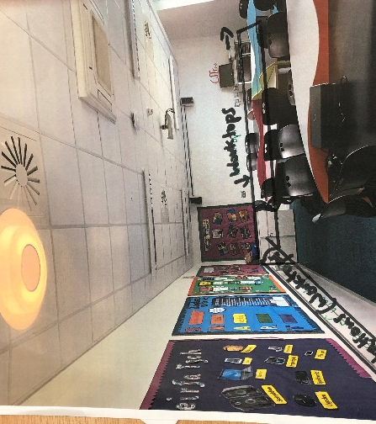

Sensory Room
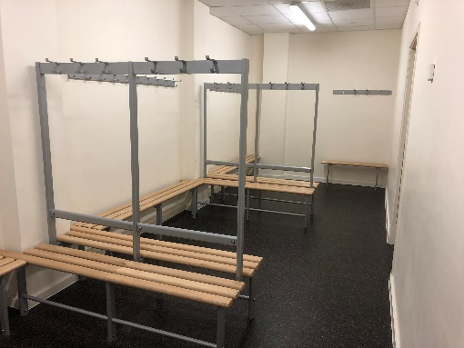 | 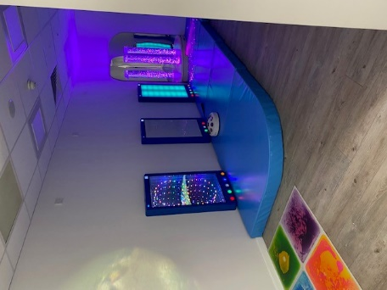
Nurture Room
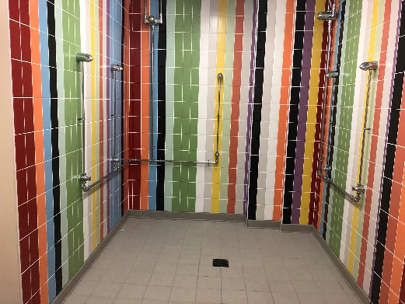
Outside Areas
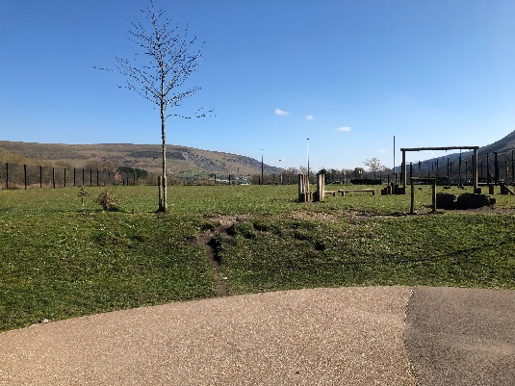

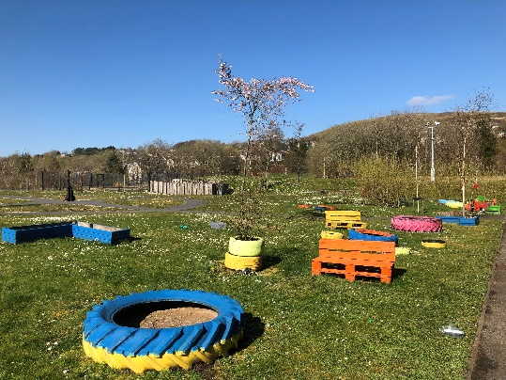

STEM/Radio Rooms
