Introducing our next Welsh champion for 2026
Rob Hughes: Inspiring Generations Through the Welsh Language
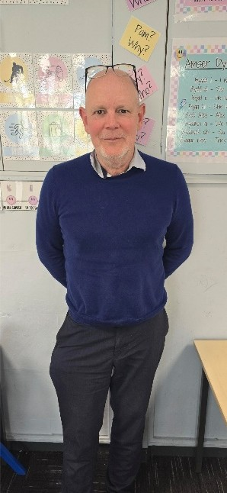
For over 25 years, Rob Hughes has been more than a teacher at Tredegar Comprehensive—he has been a champion of the Welsh language and an inspiration to hundreds of young people.
Born to Welsh parents from Pembrokeshire, Rob grew up between England and Wales. Regular visits to his Welsh-speaking grandmother sparked an early fascination with the language and a strong connection to his heritage.
Although interested from a young age, Rob began learning Welsh seriously at 24. The birth of his daughter and the passing of his grandmother motivated him to ensure his children would grow up speaking Welsh. He and his family returned to Wales permanently in 1997, settling in Quakers Yard.
Determined to become fluent, Rob studied intensively with Cymdeithas yr Iaith while working full-time, achieving fluency within a year. He later completed his PGCE and became a qualified teacher, overcoming early challenges to gain confidence in using Welsh.
At Tredegar Comprehensive, Rob focused on changing attitudes toward the language, making Welsh accessible to all. His teaching approach encouraged confident learners to inspire others, creating a positive and inclusive culture.
His impact has been lasting. Many former students continue to use Welsh in daily life, with some building careers where the language has opened opportunities—including roles in organisations such as BBC Wales.
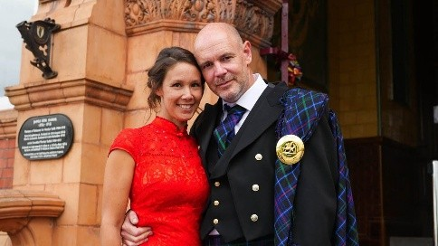
Despite ongoing challenges, such as limited A-level provision, Rob has remained committed to promoting Welsh through immersion and opportunity. His work emphasises the importance of language in shaping identity and opportunity.
Rob and his wife Naomi – who is also a Welsh learner, are actively involved in YesCymru, reflecting his belief in celebrating and protecting Welsh identity, culture, and history. He encourages students to engage with Welsh heritage through language use, cultural events, and exploring history, helping to build pride, confidence, and a strong sense of belonging.
From a child who once couldn’t understand his grandmother’s words to a teacher inspiring generation to speak them confidently, Rob’s journey is one of dedication and passion.
A Welsh Champion for 2026, he remains a lifelong champion for his students.
If you would like to nominate a Welsh champion send your nominations to Cymraeg@blaenau-gwent.gov.uk and tell us why they deserve the accolade, and we will get in touch.

