Local Welsh learner making a difference
1st May 2024
Sarah Merton, a Library assistant at Abertillery branch, has been working hard to encourage the Welsh language in Blaenau Gwent. We talked to Sarah and asked her to share her story of learning the language.
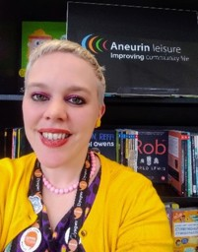
Sarah decided to learn Welsh after seeing the importance of the language and culture in France during her travels supporting the Wales National football team in 2016. She joined the Learn Welsh scheme in 2017.
After finishing all course levels of Dysgu Cymraeg, Sarah received New Speaker of the Year award from Coleg Gwent last year. “My tutor was amazing and continues to help me a lot”. Now Sarah also works as a tutor for Dysgu Cymraeg Swansea bay region, and covers both jobs part time.
Sarah began a group for Welsh learners in the area at Abertillery library a year ago. It runs every Wednesday 2-3.30 pm and welcomes all Welsh levels.
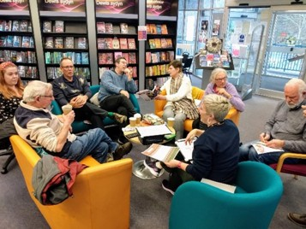
Sarah describes the group as, “very informal and relaxed, we have a cuppa and just have a chat, it’s a pleasure to support learners and help them build confidence, Abertillery used to be a Welsh speaking community so every week we aim to collaborate to reclaim our mother tongue”.
Sarah goes on to say that they want to arrange a bus and go to the National Eisteddfod in Pontypridd this year and set up more events in the area. The group also help new members who are doing the Dysgu Cymraeg exams in June.
Bethan Lawrence, Outreach library assistant for Blaenau Gwent libraries, said: "When I was in school, Welsh was just another subject to take and I didn't have the interest to learn the language, even though I am proud of being Welsh and my heritage. It was only when I was in my 30s that I found out I had strong connections with my own Welsh speaking ancestors, and I started to work on improving my Welsh language skills and learn, hoping to honour my roots. This is something I have been passionate about including in my outreach role for Blaenau Gwent libraries."
The library service in Blaenau Gwent have been trying to offer more events and activities that focus on the Welsh language. They already have a Welsh group (Clwb Cymraeg) on Wednesdays at the Abertillery site, and at the same place soon there will be a Cylch Ti a Fi (Welsh Play Group) with early years partners, Mudiad Meithrin. The group will be for children under school age to play, sing, make and just enjoy themselves in a relaxed, friendly, safe environment. You don’t need to speak Welsh as all activities are bilingual and will help with moving onto the Cylch Meithrin and onto Welsh education. A seedling provision of the new school based at Bedwellty house will lead into the new Ysgol Gymraeg Tredegar when it opens in Spring next year.
Bethan finishes by saying “We have been expanding our Welsh language books for children and adults, which include the adult learner’s series ‘ Amdani Series’. As more people are interested in the Welsh language across the borough and more Welsh schools are set up in the area, I look forward to the future and how the library service can help to grow Welsh speakers in Blaenau Gwent”.
Another learner group meets at Bryn Bach Park on Wednesday mornings 10-12am with others being organised by Menter Iaith Blaenau Gwent and Learn Welsh Gwent.
For more information about local events in our libraries go to their webpage at Aneurin leisure libraries-and-services. Or to go to the individuals mentioned in this article, just click on the links.
