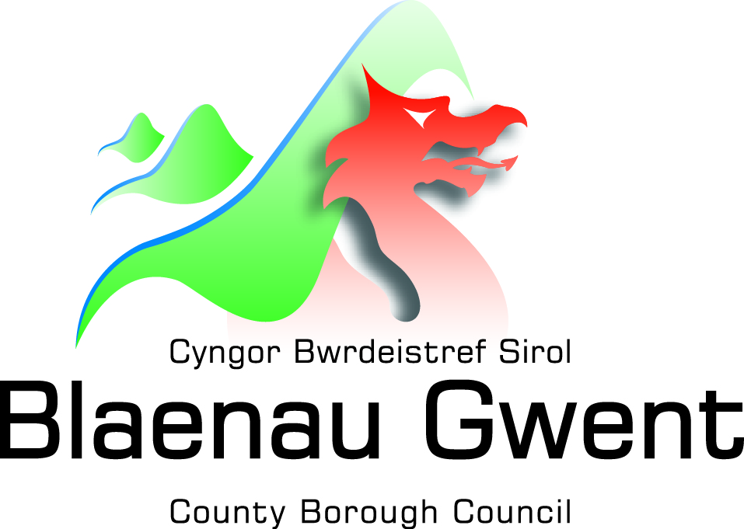
APPLICATION FOR THE REGISTRATION OF A FOOD BUSINESS ESTABLISHMENT

(Regulation (EC) No. 852/2004 on the Hygiene of Foodstuffs, Article 6(2)) (Assimilated)
This form should be completed by food business operators in respect of new food business establishments and submitted to the relevant food authority 28 days before commencing food operations. On the basis of the activities carried out, certain food business establishments are required to be approved rather than registered. If you are unsure whether any aspect of your food operations would require your establishment to be approved, please contact Blaenau Gwent County Borough Council for guidance.

- Address of establishment (or address at which moveable establishment is kept):

Post code: |  |  |  |  | Telephone no.
2. Name of food business (trading name):

3. Full Name(s) of food business operator (Owner(s)):

4. Address of food business operator:

Post code: |  |  |  |  | Telephone no.
Email:
5. Type of food business (Please tick ALL the boxes that apply):

Staff restaurant/canteen/kitchen □ Hospital/residential home/school □
Retailer (including farm shop) □ Distribution/warehousing □
Restaurant/café/snack bar □ Food manufacturing/processing □
Market/ Market stall □ Importer □
Takeaway □ Catering □
Hotel/pub/guest house □ Packer □
Private house used for a food business □ Moveable establishment e.g. ice cream van □
Wholesale/cash and carry □ Primary producer (e.g. arable, livestock) □
Food Broker □

Other (please give details):
___________________________________________________________________________________________

6. Type of business (Please tick the box that applies):

Sole Trader □
Partnership □
Limited Company □ (If Limited Company, please complete question 7. below)
Other (please give details) □

___________________________________________________________________________________________

7. Limited Company Additional Information:

Limited company name
Company no.
Registered Office address

Post code: |  |  |  |  |  | Telephone no.
8. Number of vehicles or stalls kept at, or used from, the food business establishment and used for the purposes of preparing, selling or transporting food (Please tick the box that applies):

5 or less □ 6-10 □ 11-50 □ 51 plus □

9. Water supplied to the food business establishment (Please tick the box that applies):

Public (mains) supply □ Private supply □

10. Full name of manager of the business (if different from the food business operator):
11. If this is a new business -
Date you intend to open:

12. If this is a seasonal business –
Period during which you intend to
be open each year:

13. Number of people engaged in food business (Please tick the box that applies):

0-10 □ 11-50 □ 51 plus □

Note: Count part-time worker(s) (25 hrs per week or less) as one-half
14. Please indicate whether you would prefer for the Food Authority to communicate with you in English,
or Welsh (Please tick the box that applies):

Welsh □ English □

Signature of food business operator*

Name (BLOCK CAPITALS)

Date

*Where the food business is a limited company or partnership the person signing this form must be legally authorised to act on behalf of the food business operator.

AFTER THIS FORM HAS BEEN SUBMITTED, FOOD BUSINESS OPERATORS MUST NOTIFY ANY SIGNIFICANT CHANGE IN ACTIVITIES TO THE ACTIVITIES STATED ABOVE (INCLUDING CLOSURE) TO THE FOOD AUTHORITY AND SHOULD DO SO WITHIN 28 DAYS OF THE CHANGE(S) HAPPENING.

Address to return completed form: Commercial Team, Public Protection Service, Blaenau Gwent County Borough Council, General Offices, Steelworks Road, Ebbw Vale, NP23 6AA.

Other contact details: Telephone 01495 369542. Email: environmental.health@blaenau-gwent.gov.uk

Office Use
Date of Receipt

