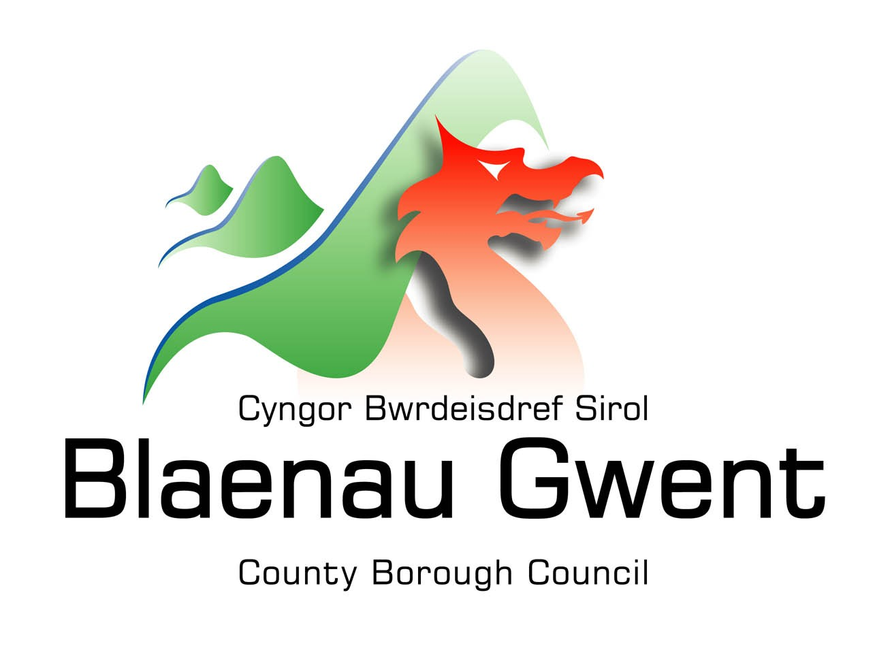
Chaperone Licence
Are you looking to become a licenced Chaperone for Blaenau Gwent County Borough Council which is regulated under the Children Young Person Act 1933/63 and the Children (Performances and Activities) (Wales) Regulations 2015?
It is a legal requirement that children engaged in public performances, working in TV, film, paid modelling or sporting activities, under a licence issued by the local authority, must be supervised by a council-approved Chaperone, unless they are in the care of their parent, legal guardian or, in certain circumstances, a teacher.
A Chaperone's first duty is to the child in their care. They are responsible for safeguarding, supporting and promoting the wellbeing of the child, and must not engage in any activity that would interfere with their duties.
Chaperones must remain with the child at all times, and have sight of the child when they are on stage, set or performing. The precise duties whilst the child is at the place of performance or activity will vary depending on the type of performance or activity. However, their main duties are to ensure that the child/children are properly supervised when not performing and have adequate meals, rest and recreation. Chaperones must also ensure that suitable changing facilities are arranged by the company or venues, with separate changing rooms for boys and girls over five.
A Chaperone can supervise up to 12 children. However, due to the demands of the performance, or the ages, gender or special needs of the children, the local authority may decide that a Chaperone may only be responsible for a smaller number of children to ensure they are safeguarded appropriately.
The Chaperone registration process includes the following:
- A completed application form
- One passport-sized photograph
- Interview
- Satisfactory recommendations from two referees
- Self-disclosure form to be completed
- Attendance on a mandatory Chaperone Training course
- Payment of the relevant fees
- As the role you have applied for involves contact with children, you will also be required to undergo the relevant vetting and barring checks, this will include checking criminal convictions and checking that you are not barred from working with children.
All information you provide will be treated as confidential and managed in accordance with relevant data protection legislation and guidance. You have a legal right to access any information held about you.
Approval to act as a chaperone will only be granted if the Authority is fully satisfied that an applicant has demonstrated his or her suitability for the role.
Blaenau Gwent County Borough Council is committed to safeguarding and promoting the welfare of children, young people and vulnerable adults. The Council expects all employees (paid or unpaid) to share this commitment.
We are committed to safeguarding and protecting our children and young people at [Organisation].
All posts are subject to a safer recruitment process which includes enhanced criminal records and barring checks, scrutiny of employment history, robust referencing and other vetting checks. Our safeguarding system is underpinned by a range of policies and procedures which encourage and promote safe working practices. On receiving your licence, you will be required to undergo annual safeguarding training to maintain safe working practice and to safeguard children and young people.
If you wish to apply for or renew your chaperone licence, please contact the Senior Education Officer on 07870 998947

